_{a}
THE WHEEL OF LIFE
XYZ trades business




WWW.buiderscoach.com.au

The Wheel of Life

The eight sections of the Wheel of Life represent Balance. Take five minutes and reflect on the areas of your life as represented on this “Wheel of Life”.
Be totally honest with yourself and assess where you are right now.
Give yourself marks out of 10 for each of these areas. 0 being abysmal, 10 being perfection
With the centre of the circle representing 0 and the circumference representing 10, mark a point in each segment to denote your score. Then join up the points.

What does you personal ‘Wheel of Life’ look like?

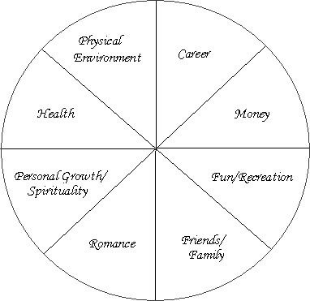

Now let’s identify what your IDEAL LIFE will look like.
Allow yourself to IDEALISE what your life would be like in the ultimate situation. VISUALISE what your life will look like in each of the Wheel of Life segments. How will it feel to be living that lifestyle, what do you see yourself doing, and how would it sound to have all of those things giving you joy and fulfilment in your life? Give yourself permission to dream like a child and create a life that you would be totally grateful for.

Now that you have had time to THINK IT, it’s time to INK IT. Write down at least 3-4 things in each segment that describe and capture what your ideal lifestyle would be.

Make sure that you are as specific as possible.

