_{a}
DRAFT BUSINESS PLAN
XYZ trades business




E: INFO@BUILDERSCOACH.com.au

Prepared by: XYZ Trades Business

Address: 123 Central Road, Anywhereville VIC 2000

Telephone: 123 456 789

Email: john@xyztradesbusiness.com.au

Website: www.xyztradesbusiness.com.au

License Number: QLD Lic #: 1200135 NSW Lic #: 177837C

ABN: 13 105 703 571

ACN: 105 703 571

Date: May 2017

Table of Contents
Executive Summary 1
Introduction 2
Management Profile 3
Goals and Objectives 5
What we do 8
Why choose us? 9
S.W.O.T Analysis 11
Digital Competitor Analysis 12
Target Market 13
Marketing Strategy 14
Social Media Strategy 15
Content Themes 17
Marketing Plan 18
Advertising Examples 20
Our Process 24
Legal Entity 26
Client Referee Reports 27
..................................................................................................37
Management Systems 44

Executive Summary

McGowan Building Services Pty Ltd, T/As McGowan Homes is a family owned and operated Custom Home Building Specialist with more than 20 years of hands-on experience building homes in Sydney, Newcastle, on the Central Coast and South East Queensland.

Established in 2003 by our principals Jeremy and Christine McGowan which have successfully delivered many building projects in that time and we pride ourselves on personalised service, individual project focus, understanding our client’s unspoken needs and exceeding their expectations.

Our focus on Risk Management; Quality; Safety; Environmental Responsibility and adopting an innovative approach to the most challenging of design requirements has seen McGowan Homes invest in the development of management systems, processes and competencies that provide the infrastructure and confidence to deliver on every project we commit to.

Introduction

McGowan Homes pride ourselves on customer satisfaction. In many case we take on the projects other contractors simply walk away from as a result of our investment in and commitment to a disciplined and systemic approach to quality construction and project management.

Our refined Risk Management approach (In accordance with AS/NZS 31000 Framework) and parallel management systems for Occupational Health & Safety Management (to AS/NZ4801:2001); Quality Management (to AS/NZS 9001:2004); and Environmental Management (to ISO 14004:20040) ensure that whatever projects we commit to are successfully delivered.

We are conservative in our approach, have the loyalty of a successful and long standing sub contract team that reflect our systems and understand our operational requirements and enjoy the loyalty of a closely knit team of employees and specialist business support personnel which allow us to respond even under the most challenging of circumstances.

Finally, when dealing with McGowan Homes you will only ever be dealing with the principals because our name is our commitment to exceeding your expectations.

Management Profile

Jeremy McGowan, Director / Builder

Jeremy is a fully qualified and licensed carpenter and builder, with more than 20 years of hands-on experience building homes in Sydney, Newcastle, on the Central Coast and in South East Queensland.

He is a builder with many great attributes, the most important of which are his honesty and desire to see clients happy with their finished product.
Jeremy prides himself of perfection, constructing to very high standards and completing all projects in a timely manner.

Christine McGowan, Administration Manager
Christine McGowan manages the administrative side of McGowan Homes.

Christine has extensive experience in an executive level of office management in various industries.

Christine has a Certificate in Office Administration, Certificate in Marketing and Diploma in Marketing Management.

Christine is an extremely organised person and ensures the smooth operation of all paperwork on projects. Throughout construction she keeps the client up to date with their progress and budget allowing them to make informed decisions throughout the project.

McGowan Building Services Pty Ltd: Organisational and Contract Management Chart

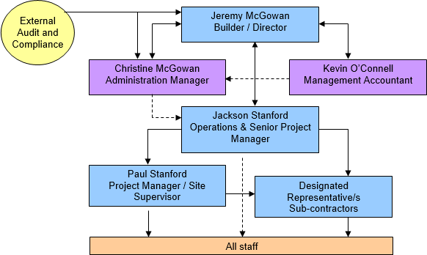

Please refer to OH&S, Environmental and Quality Manuals.

Goals and Objectives

Year 1 Goal: Increase Sales in 2016/17 Financial Year to $1M

- McGowan Building Services Pty Ltd has focused this Financial Year on rebranding and remarketing McGowan Homes to bring brand awareness to McGowan Homes. This entails going through all marketing material and implementing new and changing existing.

- McGowan Building Services Pty Ltd goal this financial year has been to engage a business coach to assist McGowan Homes is going through the 9 steps to our roadmap to success.

- Obtain and maintain relationships with Architects which refer their clients to McGowan McGowan Homes.

- Keep building custom new homes, additions and renovations whilst expanding business.

- Implement Rich Training System to improve our marketing and monitoring of statistics from our marketing via social media and e- newsletters.

- Implement project assessment questionnaire for new clients to complete.

- Implement 6 step sales process.

- Set up and use 90 day plan.

- Set up and use Customer Satisfaction Survey to clients after job completion.

- Keep in contact with existing customers to see if we can offer further assistance.

- Commence direct mail out Development Applicants.

- DL Flyer mail outs to various suburbs.

- Create a DL Flyer – Showcase brochure to send out to houses around where currently building.

- Build reliable team of contractors and trades. Implement systems and process to support McGowan Homes managing contractors and trades.

- Look at financials on ways we can cut costs, improve on quoting and product higher profits. Continue weekly reporting to review figures.

Year 2 Goal: Increase Sales in 2017/18 Financial Year to $3M

- Analyse results from previous financial year.

- Continue marketing, review existing marketing material and look at new ways to improve. Monitor statistics from marketing and keep an eye on what is working best.

- Review and keep using 90 day plan.

- Participate in training and keep up to date with latest industry changes and new systems to keep ahead in business.

- Continue to work with our business coach to assist McGowan Homes is going through the 9 steps to our roadmap to success and continues moving forward.

- Obtain and maintain relationships with Architects which refer their clients to McGowan Homes.

- Keep building custom new homes, additions and renovations whilst expanding business.

- Keep in contact with existing customers to see if we can offer further assistance.

- Continue to engage with people and create brand awareness via social media and sending out e-Newsletters.

- Continue to do direct mail out Development Applicants.

- Continue to DL Flyer mail outs to various suburbs.

- Continue to send out DL Flyer – Showcase brochure to send out to houses around where currently building.

- Build reliable team of contractors and trades. Monitor systems and processes to support McGowan Homes managing contractors and trades.

- Get advice on purchasing land to start building own homes.

- Look at financials on ways we can cut costs, improve on quoting and product higher profits. Continue weekly reporting to review figures.

Year 3 Goal: Increase Sales in 2018/19 Financial Year to $3 -$4M

- Analyse results from previous financial year.

- Continue marketing, review existing marketing material and look at new ways to improve. Monitor statistics from marketing and keep an eye on what is working best.

- Review and keep using 90 day plan.

- Participate in training and keep up to date with latest industry changes and new systems to keep ahead in business.

- Continue to work with our business coach to assist McGowan Homes is going through the 9 steps to our roadmap to success and continues moving forward.

- Obtain and maintain relationships with Architects which refer their clients to McGowan Homes.

- Keep building custom new homes, additions and renovations whilst expanding business.

- Keep in contact with existing customers to see if we can offer further assistance.

- Continue to engage with people and create brand awareness via social media and sending out e-Newsletters.

- Continue to do direct mail out Development Applicants.

- Continue to DL Flyer mail outs to various suburbs.

- Continue to send out DL Flyer – Showcase brochure to send out to houses around where currently building.

- Build reliable team of contractors and trades. Monitor systems and processes to support McGowan Homes managing contractors and trades.

- Get advice on purchasing land to start building own homes.

- Look at financials on ways we can cut costs, improve on quoting and product higher profits. Continue weekly reporting to review figures.

- Purchase land and build new homes.

What we do

McGowan Homes are Gold Coast’s Custom Home Building Specialists

We tailor solutions to your building and lifestyle needs, working within your budget and ensuring a quality finish. We are multi award winning Builder’s and are recognised with industry associations such as Master Builder’s Association and Housing Industry Association.

We custom build homes on the Gold Coast focusing on client satisfaction rather than large volume. Our team of tradesmen and suppliers have a long standing partnership with us which results in consistent high quality workmanship. Our service is tailored to the needs of each client - you can come to us with your architectural drawings ready to go; or if you haven’t got that far, we can take care of everything for you, from the early stages of design through to completion. We guide you every step of the way and provide an open flow of communication. We help you determine what is feasible within a given budget, offering alternatives and options to save you time and money, and providing advice on practicalities and block constraints etc.

As GreenSmart professionals, we also concentrate on sustainable building principles and create energy savings for life. What’s important is that your home is built according to you and your family’s ideas, dreams, and wants...and at the best price! That’s what the McGowan Homes team makes possible

Why choose us?

Quality building
McGowan Homes are specialists in building high quality customer homes. We build homes as if they were our own, taking immense pride in workmanship and striving for perfection at all times.

Quality service
We’re committed to exceeding your expectations. We undertake only a limited number of projects per year. This means that we are able to spend more time on making sure everything flows smoothly on your home whilst providing a high level of service to you.

Awards
McGowan Homes stands out from other Builder’s with our award winning service after being awarded many awards from industry professionals such as Housing Industry Association and Master Builders Association. Our most prestigious award is ‘HIA-CSR Australian Housing Awards, Custom Built Home of the Year’ finalist.

Flowing communication
Whilst we manage the building project for you, we know you’ll want to be kept in the loop. Via our secure access website, you’ll have all the details of your project’s progress at your fingertips, whether you’re at home or on the road, day or night. You will know about your expenses, progress and the selections you need to know along the way.

Premium materials
McGowan Homes only use premium materials from reputable suppliers.

Budget management
We don’t like surprises and know you don’t either. We provide a detailed quotation which covers all inclusions.

Expert team
McGowan Homes provides peace of mind with our licensed Builder/Director Jeremy McGowan will personally communicate with you on all aspects of the construction to ensure your every need is met. Our hand picked, highly skilled team who have been selected due to their specialist experience and expertise. They are the best in the business. Add to that the best subcontractors who are experts in their trade, resulting in unparalleled finishes to your home.

Safety focus
McGowan Homes are compliant with occupational health and safety requirements ensuring no unnecessary delays or compounding issues.

Fully licensed and insured
Licensed in both Queensland and New South Wales, we are fully insured for home warranty insurance, public liability, construction works and worker’s compensation.

Problem solving
We’re experts in dealing with difficult construction sites including but not limited to steep/sloping sites and overcoming design and construction conflicts. We’re always thinking outside of the square.

HIA membership
As a long term member of the Housing Industry Association, we are kept abreast of the latest industry developments, including technical and business advice.

GreenSmart accreditation
GreenSmart Professionals, we focus on sustainable building design and construction practices, including energy efficiency, water conservation, waste management and pollution prevention.

S.W.O.T Analysis

Strengths | Weaknesses
- Unique online client login system to track building progress;  - Website downloadable brochure to add value to customers whilst signing them onto the database;  - Strong & consistent brand identity across online and offline marketing collateral;  - High quality, unique content with the e-brochure and photography that can be utilised across all digital platforms;  - Website optimised for tablet and mobile for maximum search opportunities;  - High control of messaging to clients with hands on management.  - Regular monthly email via Tumblr engaging database and remaining top of mind;  - Expert of highly skills and hand picked team of tradesmen;  - Active and enthusiastic management;  - Over 20 years experience;  - McGowan Homes only undertake a limited number of projects per year.  - Workmanship Guaranteed;  - Quality Workmanship;  - OH&S Compliant. | - Only been on the Gold Coast for 5 years and competing with well established Gold Coast Builders.  - Limited social media presence and following compared to competitors, lack of consistent messaging and strategy  - Lack of in house resources and expertise to develop, implement and track online performance.  - Limited to number of jobs can take on.  - Administration resources are low at present and need increasing.  - Lake of systems and processes.
Opportunities | Threats
- Limited digital offering from competitors with an opportunity to become a digital leader;  - Loyal, happy customer base that are happy to provide testimonials and reviews;  - Lack professional builders;  - Low Interest Rates;  - Population Growth on Gold Coast. | - Highly competitive market with the threat of larger business’ with higher budgets to spend on digital marketing initiatives.  - Limited building capacity of 5-10 projects per year within current organisational structure  - Competing against local builders who have fewer overheads and are able to do job cheaper. This is because they try and cut corners and do not have OH&S Systems, appropriate insurances, etc in place.  - Interest rate increase.

Digital Competitor Analysis

Company | Speciality | Location | Additional Information |  |  |  | Social Media
McGowan Homes | Gold Coast Custom Home Building | Coomera |  | Has client communication software |  |  | Facebook: 437
 | Specialist | Waters |  | Multi award winning |  |  | Instagram: 6
 |  |  |  | Quality project gallery and testimonials |  |  | Google +: 25
 |  |  |  | Family business |  |  | Linked In: 167
 |  |  |  |  |  |  | Tumblr: Not sure #
Brett Ward Homes | Custom Home building specialist | Coomera |  | Has client communication software |  |  | Facebook: 1,273
 |  | Waters |  | Been in area some time |  |  | Instagram: 78
 |  |  |  | Client referral and good reputation |  |  | Google +: 1
 |  |  |  | Well known in area |  |  | Linked In: 47
 |  |  |  | Own factory |  |  | Tumblr: Not sure #
 |  |  |  | Has used Builder’s Coach for a number | of | years
 |  |  |  | Quality project gallery
 |  |  |  | Award winning builder
 |  |  |  | Family business
PJH Construction | Gold Coast Builders – New | Burleigh |  | Professionally marketed |  |  | Facebook: 960
 | Homes, Knock down and rebuild | Waters |  | Young vibrant team |  |  | Instagram: 697
 | and renovations |  |  | Uses Gregory Business Coaching |  |  | Google +: 4
 |  |  |  | No client log on |  |  | Linked In: 0
 |  |  |  | Quality project gallery |  |  | Tumblr: Not sure #
 |  |  |  | Award winning builder
DTL Constructions | New Home builder | Arundel |  | Good reputation |  |  | Facebook: 225
 |  |  |  | Website needs work |  |  | Instagram: 0
 |  |  |  | Has a client log in |  |  | Google +: 0
 |  |  |  | Has own factory |  |  | Linked In: 5
 |  |  |  | Not up to date with social media |  |  | Tumblr: 0
Gold Coast Unique | New Home Builder | Burleigh |  | Display home at Ormeau and Pimpama |  |  | Facebook: 335
Homes |  | Heads |  | Well known |  |  | Instagram: 0
 |  |  |  | Award winning builder |  |  | Google +: 32
 |  |  |  | Quality homes |  |  | Linked In: 6
 |  |  |  |  |  |  | Tumblr: Not sure #

Target Market
- Typically aged 35+
- Degree qualified or higher than average household income
- Not always in the industry their interest include real estate
- Internet savvy. They own multiple devices including a smartphone, ipad, desktop and laptop
- Fair amount of skill in one aspect or another of the building environment others are new to the game and are in the process of educating themselves about building.

Marketing Strategy

Marketing Objectives

1 | Increase custom home build enquiry by increasing website visitors, through increased referrals from search and social media optimization.
2 | Become an industry leader in custom home building by improving credibility and industry partnerships and a focus on PR to meet targeted revenue of  $3m-$4m by 2018-19.
3 | Increase time on site and getting jobs by evolving the client experience  through personalization with video content, mobile app and blog.

Brand Positioning
McGowan Homes is Gold Coast’s Custom Home Building Specialist. With deep building knowledge and a shared vision of personalised client service, integrity and high quality workmanship McGowan Homes one to one service supports their client’s needs to deliver the best building with quality finishes.

McGowan Homes unique selling proposition is one that centres on personalised service, the hashtag #partnerwithmcgowanhomes is one that is unique, ownable and adds value to the customers experience both digitallty and face to face. The 2017 marketing strategy will focus on strengthening this position through consistent communication and a holistic approach across all marketing channels.

Social Media Strategy

Social Channel | Likes | Content | Frequency | Online Partners | Hashtags/Content
Facebook | 437 | Video Photo  Blog Status | 3/week | Industry / Media:  - Archiecture & design  - HIA  - Sourceable.net  - Residential Architect magazine  - Grand design magazine  - The Age  - Herald Sun  - The Australian  Partners:  McGowan Suppliers such as tradesman and suppliers | #partnerwithmcgowanhomes  #mcgowanhomes
Instagram | 6 | Video Photo | 2/week |  | #mcgowanhomes  #partnerwithmcgowanhomes  #property #architecture  #design #highend #construction  #contemporary #style #luxury #home  #newhomes #builder #location  #goldcoastbuilder #customhome  #customdesign #designbuild  #knockdownrebuild
Houzz | 0 | Video Photo | 1/week |  | - 3-5 tag per image  - Photo albums per room  - 1 idea book per project  - Review from clients
Google+ | 25 | Video Photo | 3/week |  | #mcgowanhomes  #partnerwithmcgowanhomes  - Choose relevant from above and Google will add trending hastags
Tumblr | Not sure | Video Photo  Blog | 1/week |  | #mcgowanhomes #property #architecture  #modern
Linked In | 167 | Video | 2/month |  |  | - Creation of business page

 |  | Photo Blog |  |  |  | - Blogs through pulse
- Comment on & post articles within
groups
Pinterest | 8 | Photo | 1/week |  | - 3-5 tag per image  - Photo albums per room  - 1 idea book per project  - Review from clients

Content Themes

- Testimonials/Case Studies: Video and/or written testimonials and case studies from client’s McGowan Homes has worked with and the successful outcomes of partnering with McGowan Homes.

- Building Progress: Real life, on site images, potential to include video here and also a subtle way to integrate signage and branding into the posts.

- Finished Homes: Feature property of the month video / photos, show off the high quality builds that you have produced integrating the personalised service message.

- Room Focus: A key feature in a room that makes it stand out, good opportunity to tag supplier partners providing the lighting, furniture, painting etc.

- McGowan Homes Tips (industry focus): Read Industry news and provide status updates with McGowan Homes tips, starting with the 10 Essential things you must know before building your dream home as well as a meet the team video / photos with hints and tips from the experts.

- Outdoor/Luxury/Views: Aspirational, luxury, out of reach homes that get people thinking about their dream home

- Current Affair: Messages for Australia Day, Mother’s & Father’s Day, Anzac Day, Xmas, etc.

- Contract Signing: Good opportunity to promote starting new build in an area.

- Handover: Good opportunity to photograph handing over to client shows good relationships.

Marketing Plan

Marketing Channel | Tools & Tactics | Result |  | Budget
Social Media | Facebook Tumblr Instragam Houzz Google + Linked in Pinterest |  | Posts to social media to expand McGowan Homes following Highly targeted and direct communication  Building relationships with online partners and exposure to further PR opportunities  Facebook advertising to specific target market | $200  p/month
E-newsletter | Set up and manage key automated emails including checklist workflow, welcome email, blog email, monthly newsletters with more information including news, testimonials, info,  awards won, competitions, upcoming events, questions, photos & videos |  | A highly targeted medium offering customer service, support and information.  Sent regularly, brand is at constant front of mind position | $0
DL Flyer Mail out | 1-2 month send out to specific area DL marketing  brochure. |  | Increase brand awareness in conjunction with Facebook and social media marketing. | $450  p/month
Networking Events | Attend events 1-2 monthly to get brand awareness and meet like mind business people. |  | Attend networking events, these events are normally have limited people from each industry, good opportunity to get brand awareness with business minded, educated people Opportunity to meet local businesses that can McGowan Homes can work with to improve and keep competitive edge  in the business. | $100-$200  p/month
Car Signage | Signage on car to increase brand awareness |  |  | $1-2000  per/year
Large Marketing Brochure | Have at coffee shops, real estates, Architects and other for increased market awareness |  | To be sent out as part of the sales process for clients and architects.  Copies to be available for reading in coffee shops, real estate agents and Architects for increased brand awareness. | $500  per/qtr

Marketing Channel | Tools & Tactics |  | Result | Budget
Website |  | Update gallery with more images / videos of previous jobs.  Keep reviewing content to ensure up to date Update presentation and layout | - Improve site navigation and customer experience | TBD
Partner with Architects |  | Research Architects to partner with McGowan Homes  Meet at go through qualifying process | - Obtain 5 Architects that feed McGowan Homes with consistent flow of work. | $0
Autoresponders |  | Create a series of auto responders for new | - Autoresponders will be used to educate and build trust with our leads in conjunction with our sales process.  - Education with existing and completed job clients to save McGowan Homes time in explaining things to the clients. | TBD
 |  | enquiries after they receive our initial e-brochure.
 |  | Build autoresponder emails / videos to educate
 |  | clients when they sign up to build with McGowan
 |  | Homes
 |  | Build autoresponder emails after job complete, ie to
 |  | request testimonial, tell a friend and maintenance
 |  | information.
 |  | Builder autoresponder emails for suppliers for
 |  | OH&S, tips and ideas for working on
Mesh Fencing |  | Every job site as part of site set up put site fence with Mesh fencing with logo, photos, etc | - This will produce more brand awareness for McGowan Homes. | TBD
Football Club  Sponsorship |  | Building of local football club clubhouse. Field sponsorship signs | - This will produce more brand awareness for McGowan Homes.  - No cost to McGowan Homes at this stage due to donating time for building the club house. | $0
 |  | Clubhouse plarks
 |  | Marketing to Football club database and social
 |  | media (facebook and Instagram).
 |  | Logo on football jerseys
 |  | Newsetter advertising

Advertising Examples

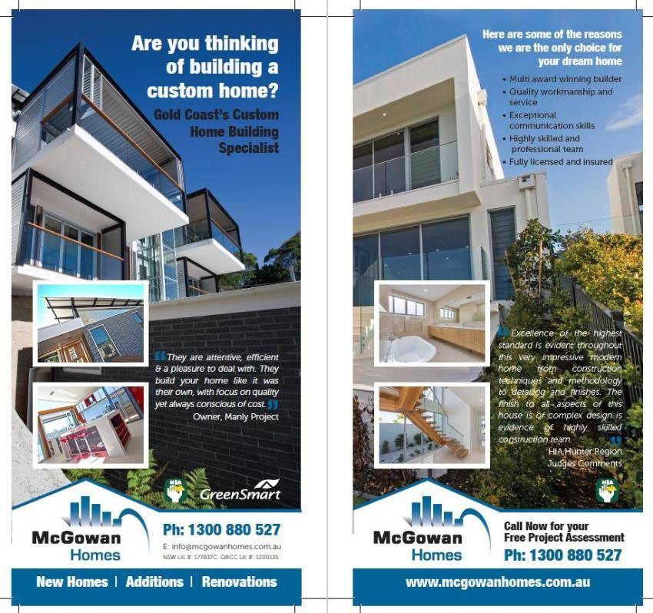
DL Flyer

Site Signage
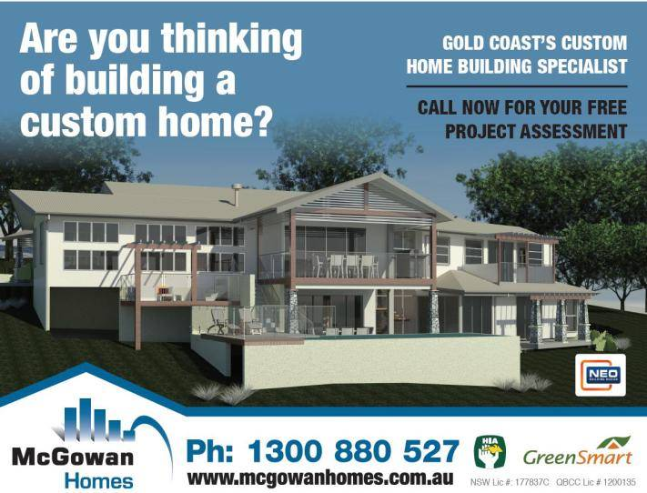

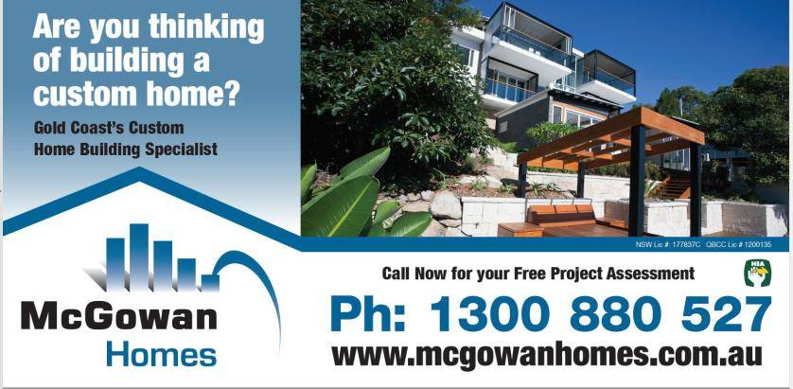
Sponsorship Signage

Website – Opt-in document
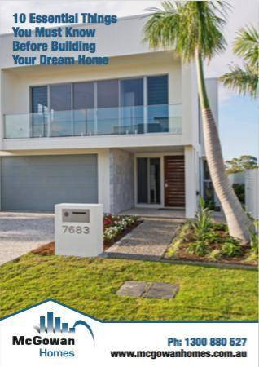

Large marketing brochure

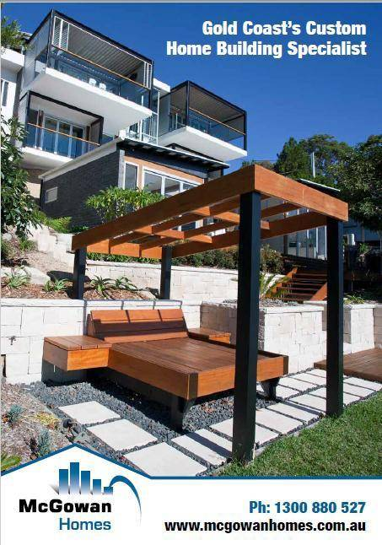

Website
McGowan Building Services Pty Ltd has compiled a website which has had excellent feedback. Our website is updated every 4-6 months or when required.

Website: www.mcgowanhomes.com.au

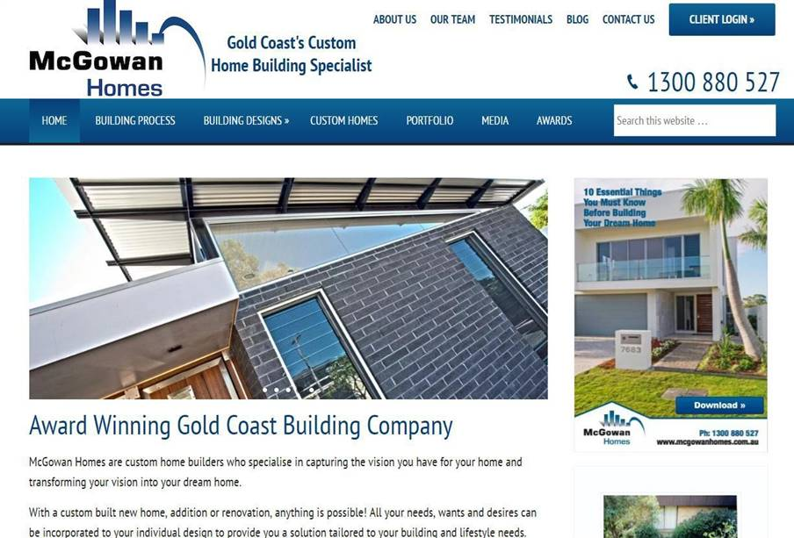

Social Media
McGowan Homes has a presence on Tumblr, Google+, Linked In, Facebook, Pinterest, Houzz and Instagram.
An e-Brochure is sent out monthly via Tumblr posts to our database.

Our Process

Building your new home is an exciting and important adventure, we want the process to be as smooth and enjoyable as possible. Here is an overview of how it all works.

Enquiry
You will receive an enquiry questionnaire and our detailed e-brochure.

Initial consultation
Meet with our Builder to discuss all of your requirements and possibilities for your home. You will also cover the location of the site and any conditions that will need to be considered. This will also be the time to discuss possible budgets and establish the level of fixtures and finishes that you are hoping to achieve. We will give you guidance with designers/architects and other professional consultants if
needed. If you already have your own detailed plans and are ready to start building, all of your requirements will be noted in order to prepare an estimate.

General review & preliminary agreement
If you feel comfortable with the initial consultation with our Builder, a preliminary agreement will be put in place to cover some of the costs involved to coordinate all of the information required to put together a very detailed quotation. The amount of the preliminary agreement depends on whether or not you have your own plans or we are needing to organise all of the necessary professionals required to prepare all of the information required for a building approval. This can vary depending on the size and the level of finish required on your project. We put a lot of effort into our quotations to ensure that everything you have asked for and what has been shown on the plans are included.

Second meeting
A second meeting will be required to review your plans, documentation and finishes to enable us to compile a detailed quotation.

Final documentation
Once you happy with all the plans and upon acceptance of our detailed quotation, final documentation is presented, which includes a detailed specification and a residential building contract which is all to be signed by both parties. Upon signing the contract a deposit will need to be paid. Once the deposit has cleared Q Leave and all necessary insurances are paid and given to the certifier to release the certified building plans.

Construction begins
We are now ready to start your building project. You will be set up with our online communications software and you will receive updates on the progress of your project. Site meetings are arranged to monitor progress of the works.

Handover
Upon practical completion, we ask you to have a walkthrough of your project with our Builder and inspect all completed works. At this point if there are any incomplete works they will be rectified for final acceptance and occupation of your home. At handover you will also receive any building reports and appliance manuals to help you to settle in.

Maintenance period
McGowan Homes will attend to any issues or rectification works that require completion during the defects liability period.

Legal Entity

Certificate of Registration of Company
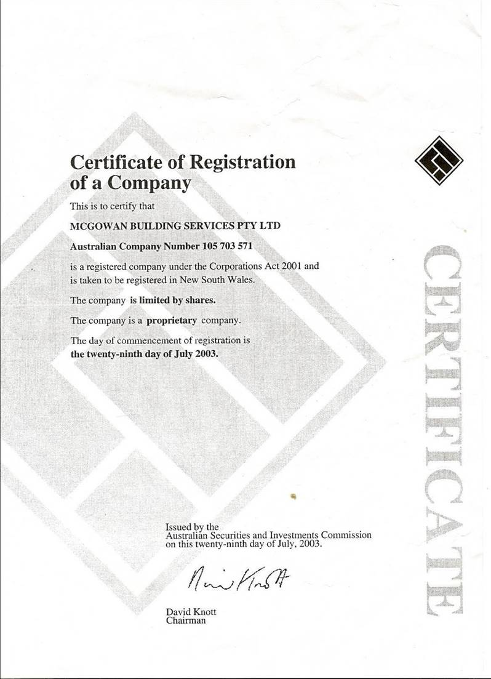

Builder’s License
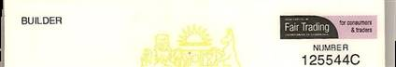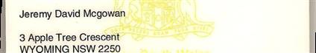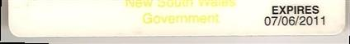

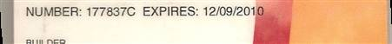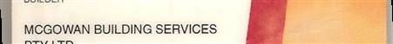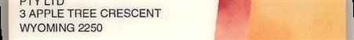

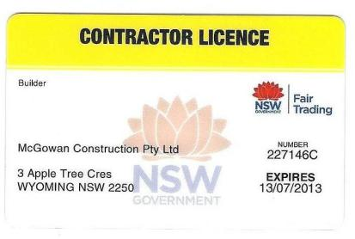

Client Referee Reports

Client: Gosford City Council
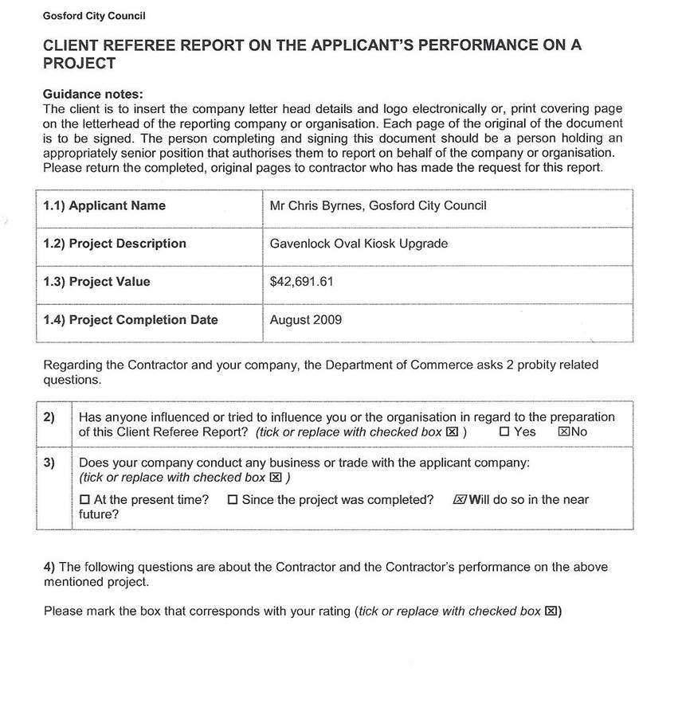

CLIENT REFEREE REPORT ON THE APPLICANT'S PERFORMANCE ON A PROJECT

The rating options to be used for the questions are:

U = Unsatisfactory M = Marginal A = Acceptable  N/A = Not Applicable | G = Good | S = Superior | u | M | A | G | s |  | NI A
4.1) Project Management (Time)  Ability to keep the project on time. To achieve milestones in the time planned. To overcome delays from inclement weather or external sources |  |  |  |  |  |  | /XJ
4.2) Project Management (Human Resources)  Ability to engage and retain sufficient numbers of staff as well as appropriately qualified / experienced staff for the project |  |  |  |  |  |  | /2SJ
4.3) Project Management (Subcontractors and suppliers to the project) Ability to manage both on-site and off-site subcontractors. Ability to effectively coordinate trade groups on the site. Ability to manage suppliers to the project |  |  |  |  |  |  | /2SJ
4 . 4) Project Management (Documentation)  Ability to maintain proper records of the project. Ability to submit claims for payment with the correct supporting evidence. Ability to request further information, drawings and reports in a timely manner |  |  |  |  |  |  | ' | /2SJ
4 . 5) Co-operation level  Ability to develop and maintain co-operative relationships between key stakeholders to the contract. Their ability to promptly inform key stakeholders of matters likely to affect the time, or cost or quality and/ or workplace safety  of the site. |  |  |  |  |  |  | /2SJ
4.6) Management of worksite safety  Ability to establish and maintain a system of work that did not repeatedly  expose the site workers and others persons to injury or harm. Ability to  control sub-contractors to ensure that they did the same |  |  |  |  |  |  | 12£
4.7) Management of site industrial relations  Ability to properly and effectively manage industrial relations matters. Ability to maintain a reasonable level of harmony on the site |  |  |  |  |  |  |  |  | !Kl
4.8) Management of environmental preservation matters  Ability to take proper measures to control any damage, harm or threats to the environment |  |  |  |  |  |  | /2SJ
4.9) Quality of the finished product  Ability to provide the correct quality of the finished product as set down in the specification. Ability to accept responsibility for defects and to fix them in a  timelv manner |  |  |  |  |  |  | /2SJ
4.10) Quality Assurance System  The level of compliance with the required Quality Assurance Standard. Their ability to provide in a professional and timely manner the information,  evidence and records in document form you needed as a client |  |  |  |  |  |  | l2SJ
4.11) Design Documents - if the job was Design & Construction (D&C) or Design Development &Construction (DD&C) (otherwise NIA)  The adequacy of their documentation in meeting the requirements of the  contract |  |  |  |  |  |  |  |  | !Kl

4.12) Maintenance - if the job was Design, Construction & Maintenance (otherwise N/A)  The adequacy of maintenance in meeting the requirements of the contract |  |  |  |  |  | /XJ

CLIENT REFEREE REPORT ON THE APPLICANT'S PERFORMANCE ON A PROJECT

- General comment regarding the Applicant's performance on the project:

..The project.flowed.smoothly throughout and the communication.was excellent betwee.n all parties...

.. Thedocumen ta t ion . was promptan d accu rate. ·· •···· ·················· •····· ··················-····· -····

.. The end product was of excellent.standard.and.the experience overall was very positive. . . . .. . .. .....

Referee's Details

... - •- ----·····-
6) Company or organisation name
I
!
l Gosford City Council
··-----· --- ···•··-······-
9) i Office Phone
!
' (02) 4304 4369
!
10 ) ; Mobile
i
11) ' Email
' 0439 945 491
i
----···---···-·-··•·-'·"- '' " ""'·• ···--····•-·--· ---
chris.byrnes@gosford.nsw.gov.au
12) Signature
I
'
I
l
Name (please print)
j Chris Byrnes
••..'
14)
03/03/10
'
Date
13)
!
j
Project
Your role with regard to the ! Project Manager
8)
l Project Officer I Open Space & Leisure Services
;
Your current position title
7)

Thank you for your participation in this activity

Client: NSW Government: Public Works Project Management

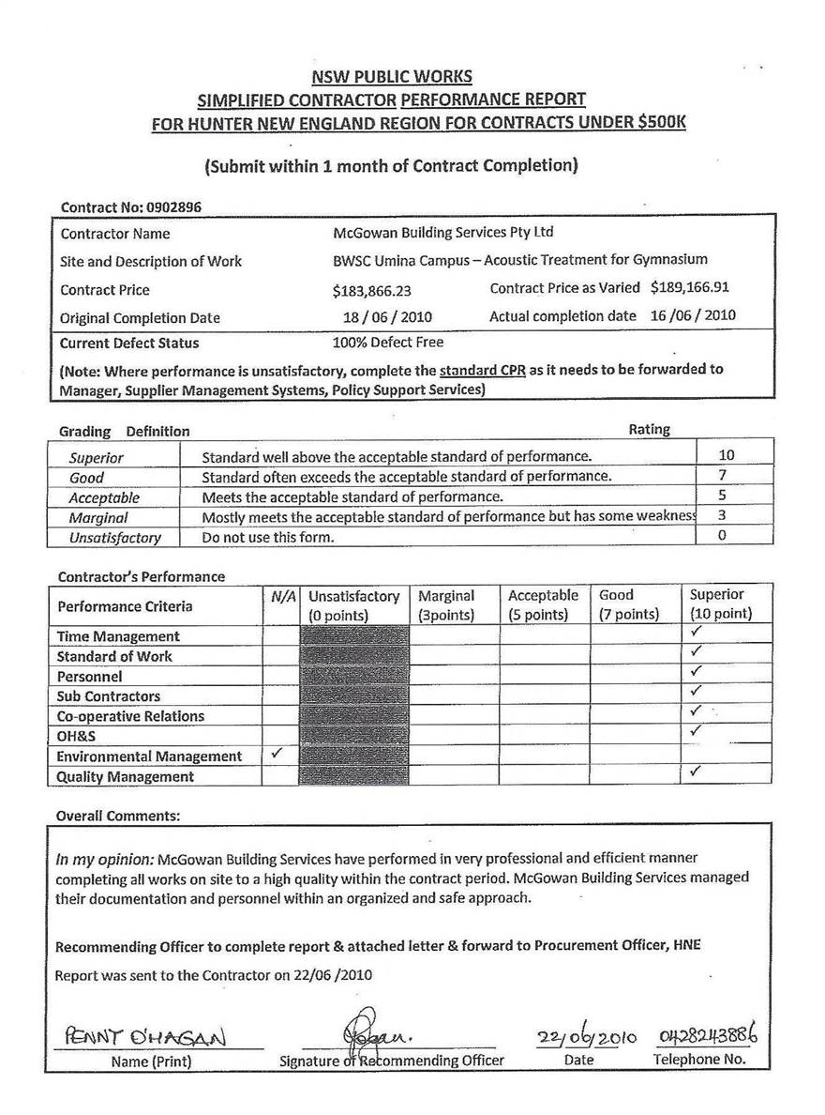

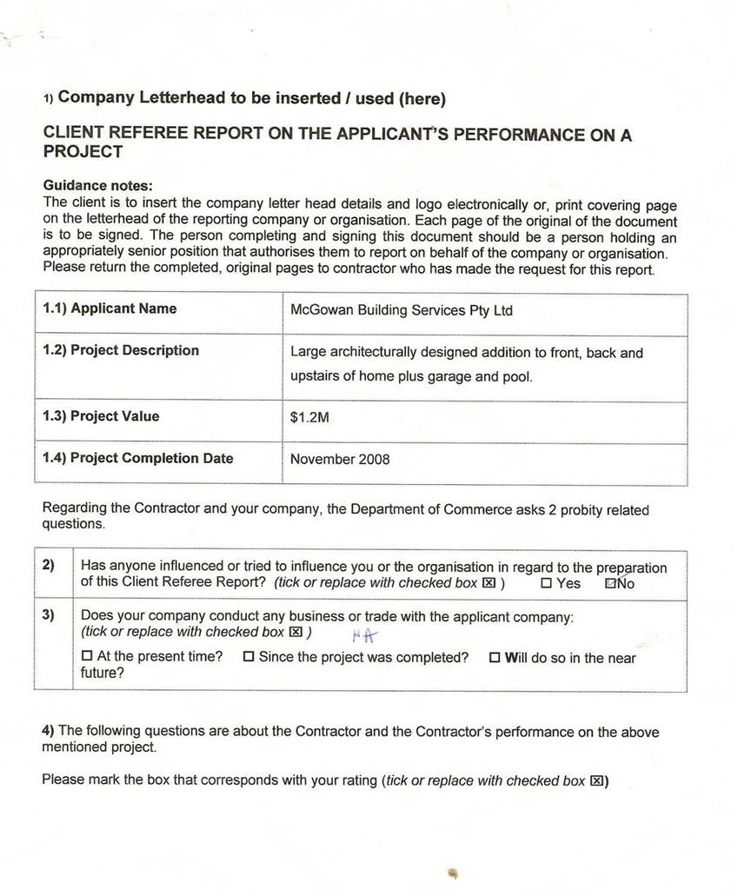Client: Claudia Holmes, 87 Bower St, Manly NS

CLIENT REFEREE REPORT ON THE APPLICANT'S PERFORMANCE ON A PROJECT

The rating options to be used for the questions are:

U = Unsatisfactory M = Marginal A = Acceptable G=Good S = Superior  N/A = Not Applicable | u | M | A | G | s | N/A
4.1) Project Management (Time)
Ability to keep the project on time. To achieve milestones in the time planned. To overcome delavs from inclement weather or external sources
4.2) Project Management (Human Resources)  Ability to engage and retain sufficient numbers of staff as well as appropriately qualified / experienced staff for the project |  |  |  |  |  | V
4.3) Project Management (Subcontractors and suppliers to the project) Ability to manage both on-site and off-site subcontractors. Ability to effectively coord inate trade groups on the site. Ability to manage suppliers to the project |  |  |  |  |  | V
4.4) Project Management (Documentation)  Ability to maintain proper records of the project. Ability to submit claims for  payment with the correct supporting evidence. Ability to request further information, drawirn:is and reports in a timely manner |  |  |  |  | /
4.5) Co-operation level  Ability to develop and maintain co-operative relationships between key stakeholders to the contract. Their ability to promptly inform key stakeholders of matters likely to affect the time, or cost or quality and/ or workplace safety of the site. |  |  |  |  | v | /
4.6) Management of worksite safety  Ability to establish and maintain a system of work that did not repeatedly  expose the site workers and others persons to injury or harm. Ability to  control sub-contractors to ensure that they did the same |  |  |  |  | /  ii
4.7) Management of site industrial relations  Ability to properly and effectively manage industrial relations matters. Ability to maintain a reasonable level of harmony on the site |  |  |  |  | /  1
4.8) Management of environmental preservation matters  Ability to take proper measures to control any damage, harm or threats to the environment |  |  |  |  | l v
4.9) Quality of the finished product  Ability to provide the correct quality of the finished product as set down in the specification. Ability to accept responsibility for defects and to fix them in a  timely manner - |  |  |  |  | / | V
4.10) Quality Assurance System  The level of compliance with the required Quality Assurance Standard. Their ability to provide in a professional and timely manner the information,  evidence and records in document form vou needed as a client |  |  |  |  | l v
4.11) Design Documents - if the job was Design & Construction (D&C) or Design Development &Construction (DD&C) (otherwise N/A)  The adequacy of their documentation in meeting the requirements of the contract |  |  |  |  |  | /

.....

/
4.12) Maintenance -if the job was Design, Construction & Maintenance fotherwise NIAi  The adequacy of maintenance in meeting the requirements of the contract |  |  |  |  | 1/17

CLIENT REFEREE REPORT ON THE APPLICANT'S PERFORMANCE ON A PROJECT

5) General comment regarding the Applicant's performance on the project:

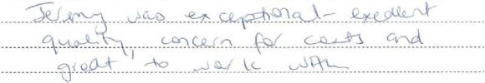

Referee's Details

I  I 61  I  I | Company or organisation name | n/a
7) | Your current position title | Owner
8) | Your role with regard to the Project | Owner
9) | Office Phone | 0403 386 578
10) | Mobile | 0403 386 578
111 | Ema il | claudia@mumiandbubi.com.au
12) | Signature | r,,-J-hho<J/
13) | Date | \ \ · \'2 ·o:/·)
14) | Name (please print) | Ms Claudia Holmes ..

Thank you for your participation in this activity

Client: Star Scientific, West Gosford

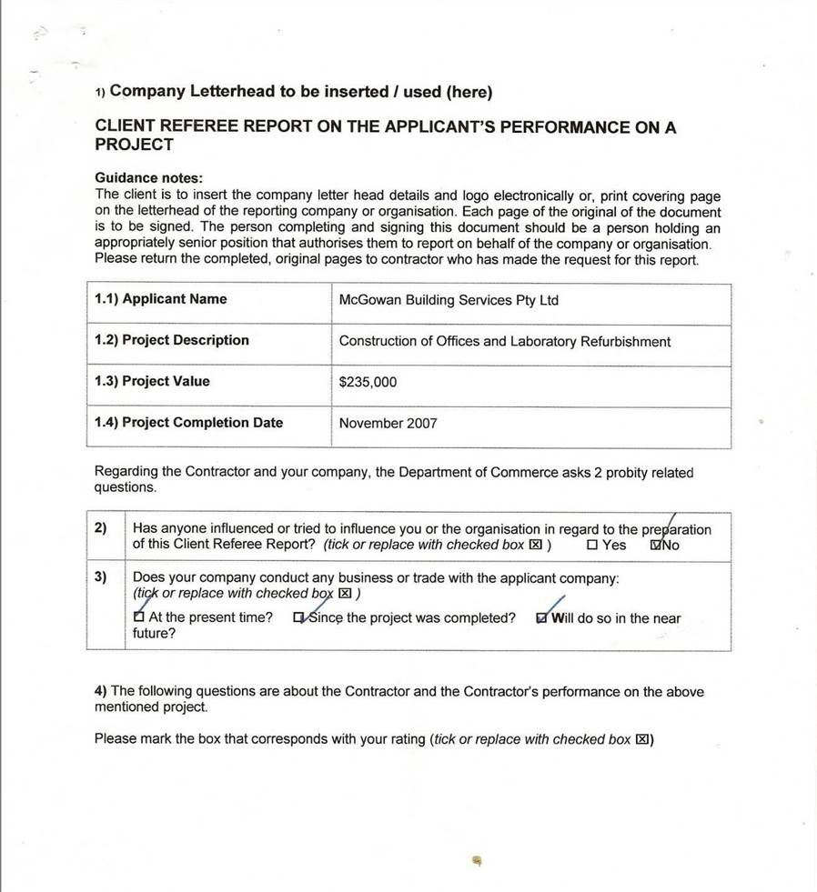

CLIENT REFEREE REPORT ON THE APPLICANT'S PERFORMANCE ON A PROJECT

The rating options to be used for the questions are:

U = Un satisfactory M = M arginal A = Acceptable G = Good S = Superior  NIA = Not Applicable | u | M | A | G | s | N/A
4.1) Project Management (Time)  Ability to keep the project on time. To achieve milestones in the time planned. To overcome delays from inclement weather or external sources |  |  |  |  |  | I
4.2) Project Management (Human Resources)
Ability to engage and retain sufficient numbers of staff as well as appropriately Qualified I experienced staff for the project
4.3) Project Management (Subcontractors and suppliers to the project) Ability to manage both on-site and off-site subcontractors. Ability to effectively coordinate trade groups on the site. Ability to manage suppliers to the project |  |  |  |  | I
4.4) Project Management (Documentation)  Ability to maintain proper records of the project. Ability to submit claims for  payment with the correct supporting evidence. Ability to request further information, drawings and reports in a timely manner |  |  |  | /
4.5) Co-operation level  Ability to develop and maintain co-operative relationships between key stakeholders to the contract. Their ability to promptly inform key stakeholders of matters likely to affect the time, or cost or quality and I or workplace safety  of the site. |  |  |  | I
4.6) Management of worksite safety  Ability to establish and maintain a system of work that did not repeatedly  expose the site workers and others persons to injury or harm. Ability to  control sub-contractors to ensure that they did the same |  |  |  |  | ./
4.7) Management of site industrial relations
Ability to properly and effectively manage industrial relations matters. Ability to maintain a reasonable level of harmony on the site
4.8) Management of environmental preservation matters  Ability to take proper measures to control any damage, harm or threats to the environment |  |  |  |  |  | I
4.9) Quality of the finished product  Ability to provide the correct quality of the finished product as set down in the specification. Ability to accept responsibility for defects and to fix them in a  timely manner - |  |  |  |  | ./
4.10) Quality Assurance System
The level of compliance with the required Quality Assurance Standard. Their
ability to provide in a professional and timely manner the information, evidence and records in document form you needed as a client
4.11) Design Documents - if the job was Design & Construction (D&C) or Design Development &Construction (DD&C) (otherwise N/A)  The adequacy of their documentation in meeting the requirements of the contract |  |  |  |  |  | /

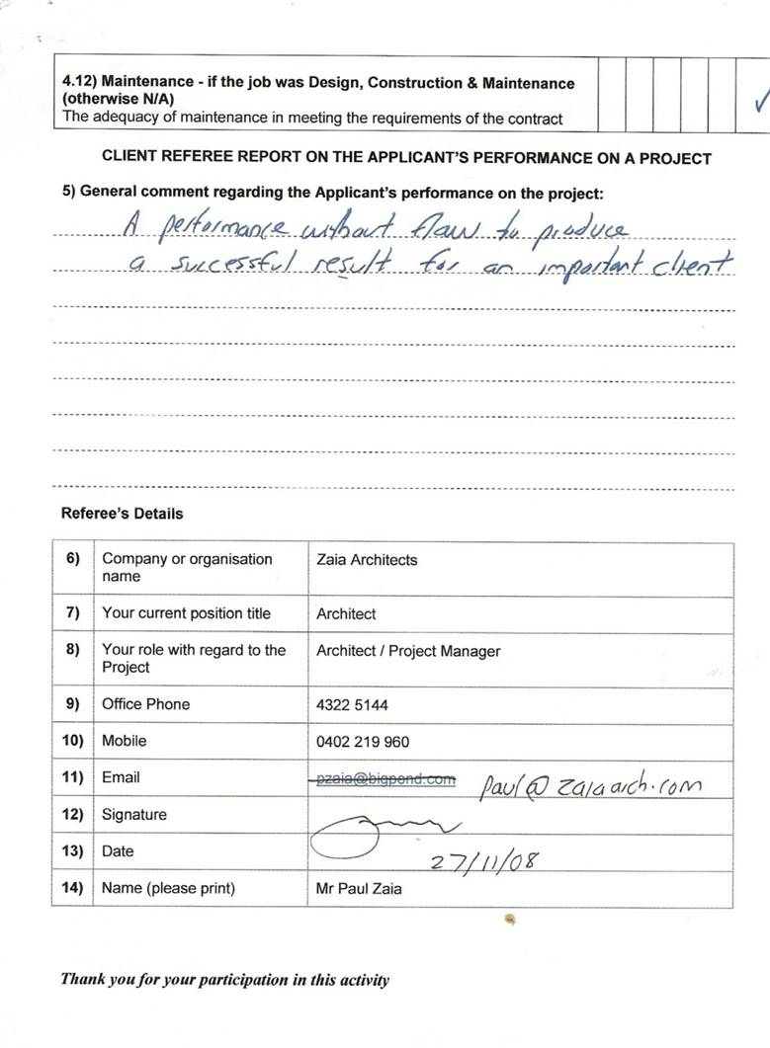

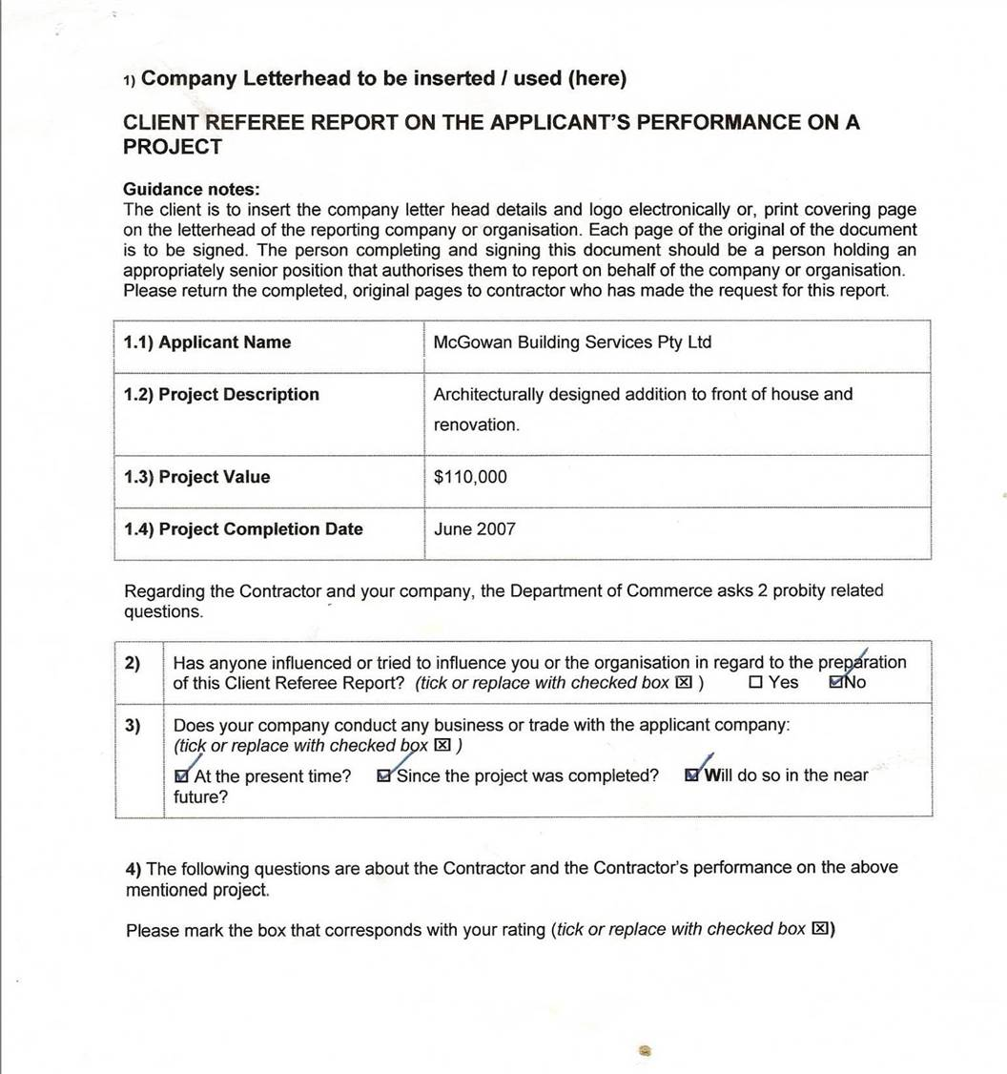Client: Paul Zaia, Narara NSW

CLIENT REFEREE REPORT ON THE APPLICANT'S PERFORMANCE ON A PROJECT

The rating options to be used for the questions are:

U = Unsatisfactory M =Marginal A =Acceptable G= Good S =Superior  NIA= Not Applicable | u | M | A | G | s | NIA
4.1) Project Management (Time)  Ability to keep the project on lime. To achieve milestones in the time planned. To overcome delavs from inclement weather or external sources |  |  |  | /
4.2) Project Management (Human Resources)  Ability to engage and retain sufficient numbers of staff as well as appropriately qualified/ experienced staff for the proiect |  |  |  |  | /
4.3) Project Management (Subcontractors and suppliers to the project) Ability to manage both on-site and off-site subcontractors. Ability to effectively coordinate trade groups on the site. Ability to manage suppliers to the project
4.4) Project Management (Documentation)  Ability to maintain proper records of the project. Ability to submit claims for  payment with the correct supporting evidence. Ability to request further information, drawings and reports in a timely manner |  |  |  | I
4.5) Co-operation level  Ability to develop and maintain co-operative relationships between key stakeholders to the contract. Their ability to promptly inform key stakeholders of matters likely to affect the time, or cost or quality and / or workplace safety  of the site. |  |  |  | /
4.6) Management of worksite safety  Ability to establish and maintain a system of work that did not repeatedly expose the site workers and others persons to injury or harm. Ability to control sub-contractors to ensure that they did the same |  |  |  |  | ./
4.7) Management of site industrial relations  Ability to properly and effectively manage industrial relations matters. Ability to maintain a reasonable level of harmony on the site |  |  |  |  |  | /
4.8) Management of environmental preservation matters  Ability to take proper measures to control any damage, harm or threats to the environment |  |  |  |  |  | ./
4.9) Quality of the finished product  Ability to provide the correct quality of the finished product as set down in the specification. Ability to accept responsibility for defects and to fix them in a  timely manner e |  |  |  |  | /
4.10) Quality Assurance System  The level of compliance with the required Quality Assurance Standard. Their ability to provide in a professional and timely manner the information, evidence and records in document form you needed as a client |  |  |  | I
4.11) Design Documents - if the job was Design & Construction (D&C) or Design Development &Construction (DD&C) (otherwise NIA)  The adequacy of their documentation in meeting the requirements of the contract |  |  |  |  |  | /

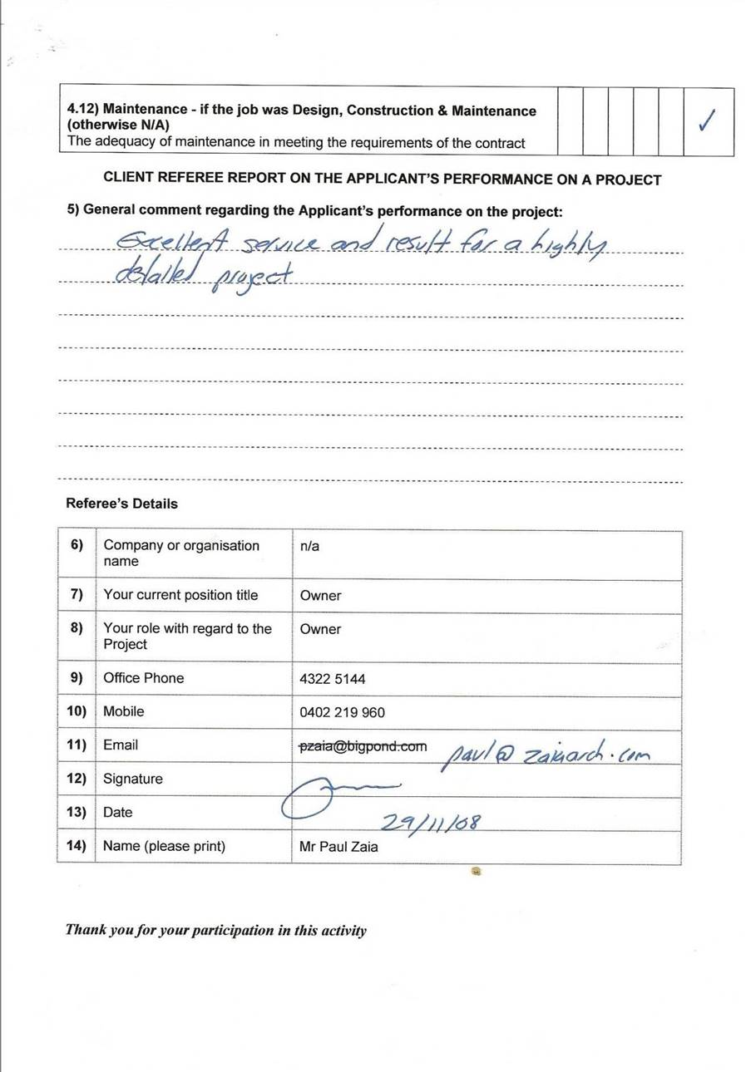

Client: Heather Shield, Narara NSW

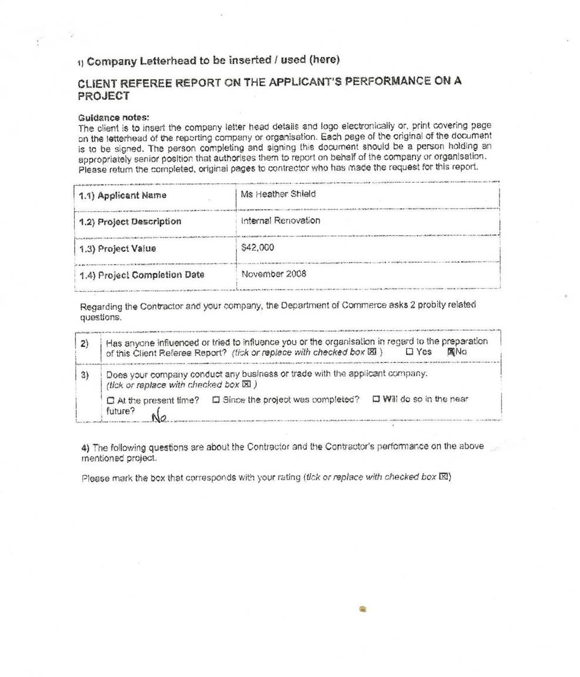
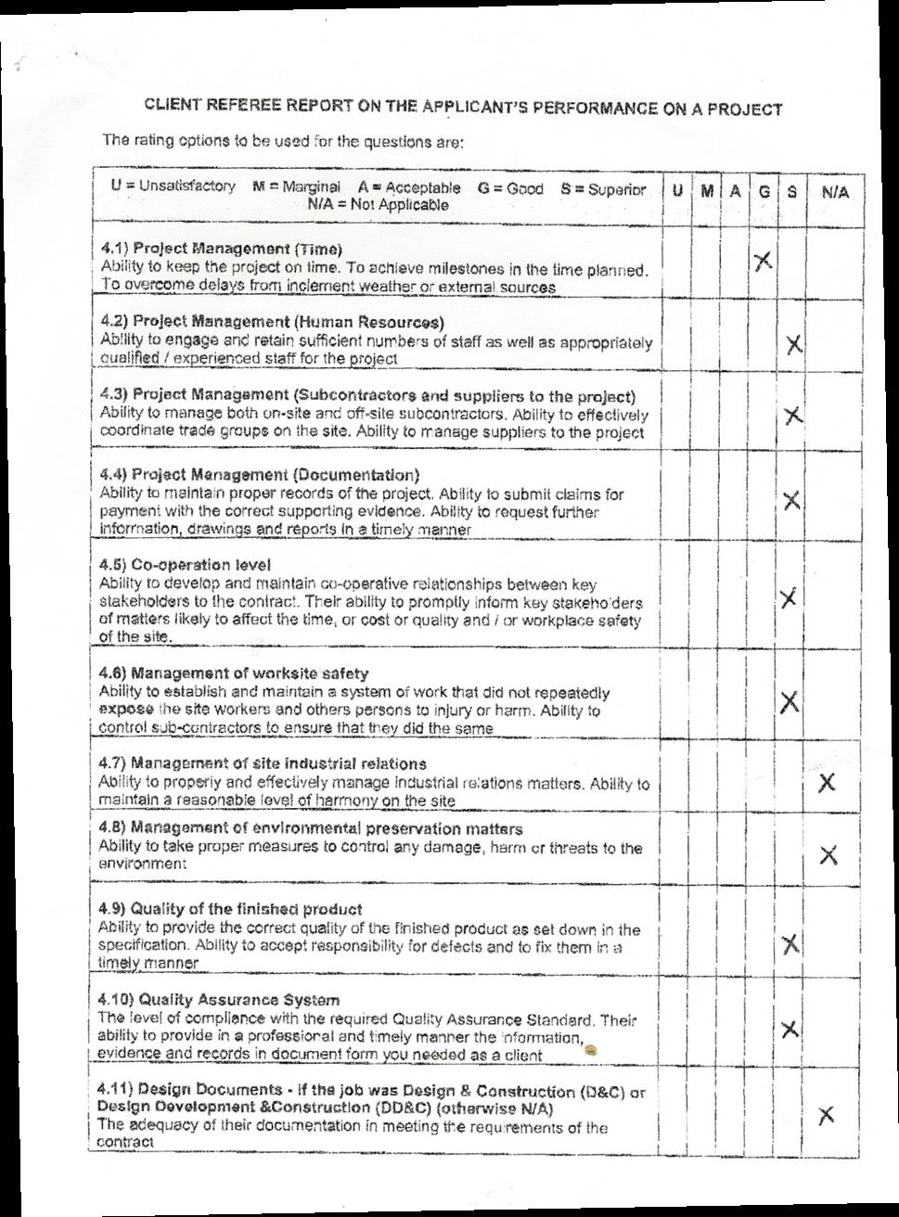

I ! I J
I
I
I
14.12) Maintenance• if tho job Wi.l!l Design, Construction & M.ainienance I I I

I(otherwise NIA) I I
The adr;c:uacy of maintenance in meeting the requirements of the contract LL
CUENT REFEREc REPORT ON THE APPLICANT'S PERFORMANCE ON A PROJECT
)< I

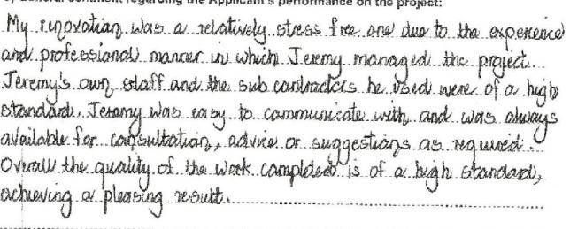
. ,...,.. . -·.-------.-· -. --· - ... .. ... ... . ..... - ₋₋...... .. ... . --- .. ₋ - -- - . -.. ...... ...
Ref ree's Details

. - ₋_ ,.,. .... .. ..... . . - ------·.·.

--- --- ---·

1 "·•· - - ":· •..-······ - ·- ·- -·· ,,.,..,.,.......- ......... ,,_,... , _ _ ..,_, .. ,..._._.,,.. ,._

- --·-- . ............ .,........._., .
-····- -···•-...-," ... ·· ·-· ··- ·······.,"'!

  - 6) ! Company or org<1n i sation I11/a
1r··-![1··n·a-·m-.·.e·---...--··--· ··---..·---
-!·- -- -- -- -·---· ·-· •·•• ..- ... .... ---•····--···----- ··- .... ......... ·-··-·..··- ..····· ,

I•>J ;;;:::;rw ,h regacd ;, I.•,.,
; 7) ' Your current position title ; Owner .
Owoe c .,..
. . ... .. ·- ... .. .. .. . . ·- ·- - - -. •. . . . .. . . ·· --
·r
- · ·1·

,( 9 ) ·;- j" O ffice. Pr one,. , .. ··_..
......... ,,_ '!"4" 3 25- 1692 ·-- - · .. -- -· ······ · • ··--··- ········-····-·- ·-·----·- -1

I· '•· ... ·1 ........, -· ..·-- -·-...--·.·-·-··....•·-- -·....... ... ....... .··--·. --·· ·---·..··--.............-.··-··• ..... ................ ........ .
!: 10) i Mob ile j 0414 649 656 j
...I.......' .. ........ . ..... ........ - - - --- ·· · ..·-- .• . ............,.... ........- .. ...-_..... ..... ..... .. . ........·- ··-·····-··- ..... ·· -·- ...'
! :11) i E rr.all ; Heather.Shield 8@r,0in M1.in it ;1.nsw.gov .a u j
f... - - · · - ....._..... __ ,...,. ...... ----···-·I··· -· ....., ,........·- -···-·-·· ,--··-··-···-·_.,-.........- ·-----·,

I::::1 ::,aW<e.... - .,... ·i l' .. --... ...·--.-·- -... . !
. i1;4 ) · !,-Na re.i (please print_) ,..-.-. ·· ; MsH ! : :. l d .. ··- ..- .·.•- •··- ·--··-- -- -·-- ·• --·-.-.····--·- ;

:..·-·--. ....-. ....-·...·-·-··-··- - .. -··........L.........---•··..... _.._. .._..._..____ .. ...........-.......... ......... ..,... _.....,

r/Ja11k you fbr your participation it, thfs a.cri1-ity
'

Management Systems

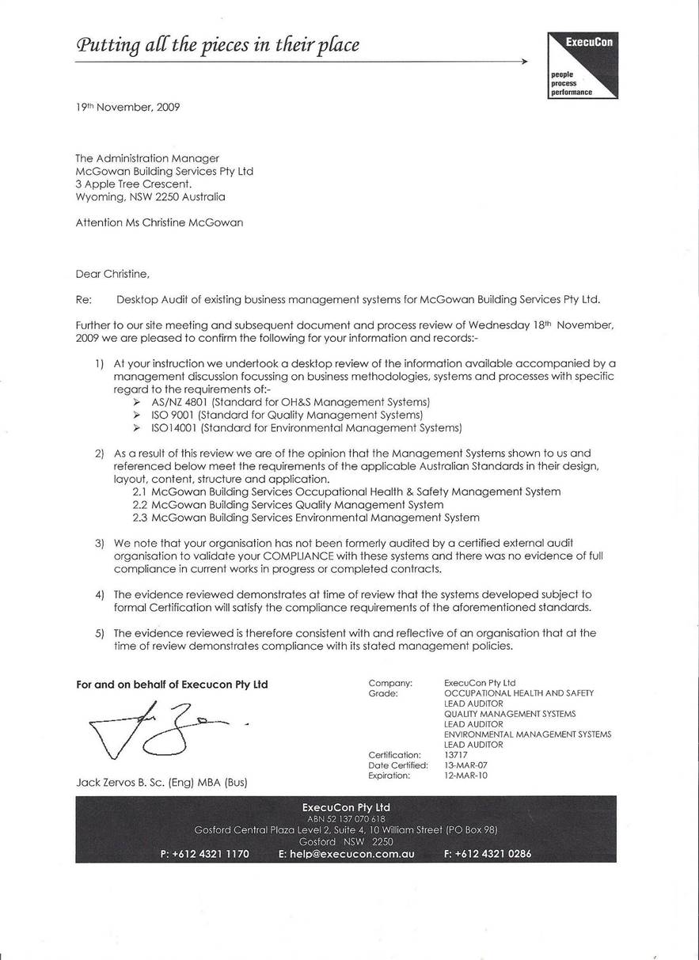Letter of Complia
24th March, 2010 Our Ref: MBS/j z_ cm/ez/23/03

The Administration Manager McGowan Building Services Pty Ltd 3 Apple Tree Court
Wyoming, NSW 2250

Attention Ms Christine McGowan Dear Christine,
Re: Management System Compliance and Accreditation McGowan Building Services Pty Lt d (ABN 13105703571)

Further to our site meeting and subsequent document and process review of Tuesday 23rd March, 2010 we are pleased to confirm the following for your information and records:-
- At your instruction we undertook a desktop review of the information available accompanied by a management discussion focussing on business methodologies, systems and processes with specific regard to the requirements of:-
►
AS/NZ 4801 & BS18001 (Standard for OH&S Management Systems) ISO 9001 (Standard for Quality Management Systems)
►
►
ISO14001 (Standard for Environmental Management Systems) AS4360 (Standa r d for Risk Management)
►
- Our observations as a result confi rm that whilst your organisation does not formerly satisfy or demonstrate full compliance with these standards at time of review there is existence of documented management systems and policies in all these areas within your organisation including evidence of your adherence to and compliance with these systems that meet the auditable requirements of these Standards.
- Furthermore we acknowledge the management commitment towards ongoing implementat ion of and compliance with auditable management systems in accordance with and/ or consideration of these standards to a level meeting the requirements of exte rnal th ird party certification.
- , The evidence reviewed at this point is therefore consistent with and reflective of an organisation that can demonstrate existence of and a commitment to compliance with Occupational Health & Safety, Quality and Environmental Management Systems and it's stated management pol icies and has made a commitment towards full system implementation, compliance and accreditation.

Yours Faithfully
For and on behalf of ExecuCon Pty Ltd

Jack Zervos B. Sc. {Eng) MBA {Busl
Director
Inte rnational Regi ster of Certificat ed Auditors (JRCA) Certification Number 01185553 (Third Party Management Systems as Agent for Execucon Pty Ltdf
Occupational Health & Safety Management Systems - BS 18001:2007: Lead Auditor Quality Management Syste ms- 1S0 2008: Lead Auditor
En vironmental Management Systems ISO 1400 1:2004: Provisio nal Auditor

