_{a}
XYZ TRADES BUSINESS

SPECIALIST TRADES BUSINESS MARKETING BROCHURE

John Citizen
XYZ TradesCompany
123 Central Road, Anywhereville VIC 2000
P: 123 456 789
E: john@xyztradesbusiness.com.au

www.xyztradesbusiness.com.au

17 reasons why Build On Home Improvements is
your preferred Renovations and Additions Specialist:

- Build On is Sydney’s Upper and Lower North  Shore Additions and Renovations Specialist. This is our area of expertise and we have 31 years of experience in the trades industry. We will always overcome challenges that arise from design issues giving you peace of mind that your dream home is in the hands of an expert.  - We have proven that we stand out with our award winning service after being awarded a Housing Industry Association finalist award for "Excellence in Renovations". Build On has surpassed many industry standards which in turn has made Build On one of Sydney's most sought after trades companies.  - Free Consultation and Quotations- we pride ourselves on establishing and meeting your needs in functionality, aesthetics, quality, cost and timing.  - Superior Trades Knowledge- previous experience in all facets of construction. You have peace of mind you’re dealing with an industry specialist.  - Housing Industry Association Member- continuous education and skill training. You can feel confident that only the most qualified and skilled tradespeople are working on your project.  - We will work with you to custom mould your home to your individual needs and preferences.  - Your dream home is our inspiration. We will be there with you to create your home every step of the way.  - We provide peace of mind with our highly skilled team who have been selected due to their specialist experience and expertise. They are the best in the business. Not only are we great trades we are highly skilled carpenters and we understand what it takes to design and build great homes. | - Build On builds homes of the highest standard;  we collaborate with specialist architects and expert engineers to achieve spectacular results on any site.  - We offer a unique life time guarantee on our work in conjunction with our ongoing maintenance program. This will give you peace of mind knowing that your home will be kept in premium condition for life.  - Our online project management system allows us to work in collaboration so you know about expenses, progress and the selections you need to make along the way. Along with regular site meetings to update you on progress, any issues and possible options and upgrades available, this will ensure you are kept up to date and informed.  - If you are unavailable for site visits our online project management system will keep you up to date no matter where you are.  - We pride ourselves with client centric philosophy and our client obsession. So we  consider what’s important to you every step of the way.  - Our director Arthur Donnelly will personally communicate with you on all aspects of the construction to ensure your every need is met.  - We take the time to generate monthly reports on progress and approaching works for the upcoming month.  - We select only the best subcontractors who are experts in their trade, resulting in unparalleled finishes to your new home.  - You will never be left wondering. We keep you informed of the job progress from start to finish and we’re always more than happy to answer your questions. It's a journey we both should enjoy.

Our Guarantee:
In our quest for superior quality and highest level of customer satisfaction, we guarantee all of our clients:

➔ Full support and progress communication

➔ Full 7 year structural warranty

➔  Unique 24 week maintenance period

➔ Project completed on time

➔ Your vision is our priority - We want your home to be your castle, any changes you choose to make at any stage of the project are your choice because we want you to be 100% satisfied with your home.

➔ Every home goes through our 725 Point Quality Assurance Check List so even the smallest details are checked.

➔ As a Registered Master Trades business your home will be built with the utmost skill and quality and a Master Trade’s guarantee for your peace of mind.

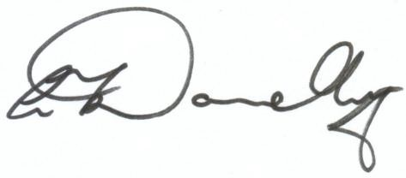
ARTHUR DONNELLY

MANAGER/DIRECTOR



What We Strive For:

  - Build On is dedicated to providing exceptional service to our clients
  - To exceed our clients’ expectations

  - To maintain our 100% performance record and to be continually associated with excellence

  - To put it simply to be the very best at what we do
  -  Say with pride. “we built this”

Testimonials:

Unit, Internal Renovations…
“From start to finish the whole project was made easy by the professional approach of Arthur Donnelly from Build On Home Improvements. I was so impressed by the quality of
work carried out that I engaged Build On Home Improvements yet again two years later for renovations to my next property, with fantastic results.”- Tony McDermott

Second Storey Additions…
“Build On Home Improvements was recommended to us by our architect who had used them on numerous other projects. Arthur has become well known to us over many years. On three separate occasions Arthur and the Build On team have returned to carry out kitchen, bathroom and a second storey addition. We cannot express our satisfaction highly enough
and have no hesitation in recommending Arthur and the team at Build On to anyone considering renovations or extensions to their home. ”- Penny& Alan Hellier

Complete Renovations…
“Dear Arthur, Just a Quick note to once again thank you for the fantastic job you did on our renovation. I have just had my father visit from the UK. He is a trades business from the old school and your workmanship even stood up to his standards plus my dad does not waste words on praise unless it has been highly earned. Thanks again for making our renovation experience
as pleasant as possible. I will recommend you to all my friends and family. Once again thank you Build On for making my house a home.”- Vicki & Robert Dening

About Us:
We think it is important that you take the time and get to know us.

Located in Sydney’s Inner West Build On specialises in residential renovations and additions. We work with expert architects and specialist engineers to create truly inspiring homes. We pride ourselves on our customer relationships that we develop during the course of construction and long after the project is completed. If you already have plans we’re happy to get working on your dream home straight away.

Build On Home Improvements is a small, family owned business. We are a design and construction company located in Sydney’s Inner West. The director and master trade, Arthur Donnelly, started out with his father over 30 years ago as an apprentice carpenter. Career progression soon followed.

After studying business at TAFE NSW and being eligible for a trades license, Arthur formed Build On Home Improvements. Build On started out with small sub contract carpentry projects, which assisted Build On to grow into the business it is today.
Arthur has worked in many aspects of property development, from design through to construction on a variety of projects. Build On Home Improvements prides itself on being one of Sydney’s most friendly and supportive trades that specialises in transforming your home.

Our aim at Build On Home Improvements is to deliver whatever the clients’ needs are. Whether it is a large or small budget, Build On can tailor your project to suit your needs.

Build On has completed a multitude of successful renovations and extensions which is self evident when you look at the amount of repeat referrals received from our satisfied customers. Our main focus at Build On is customer service. It’s your home you want to change and Build On will guide you through it with our expertise.

Build On has a network of happy team members and competent trades people which enables the company to provide exceptional work on all types of residential construction successfully and safely.

Whether your project is small or large, we will be happy to sit down with you to discuss your needs and assist in seeing them become a reality. With Build On you can achieve your goals. Consider Build On for your next project because at Build On we understand that your house is your home, so why leave – Build On…

The step by step procedure of how we do work:

- Step 1- Free Site Inspection. Meet you on site to discuss construction options and your requirements

- Step 2- Designing your home. You tell us what style home you have in mind and we can recommend the draftsman or architect that we think is most experienced to fulfil your needs. We then work as a team to give you the very best in design service

- Step 3- Tendering Process. Prepare a budget estimate or quotation for you with site works and all other inclusions

- Step 4- Tender Acceptance. Discuss changes and additions to the project and gain your approval to proceed with the works

- Step 5- Signing of Contracts. Prepare contract for you to sign. Develop a time line program for the project and arrange a start date

- Step 6- Commence Construction Works. You will receive updates on the process of the project. Site meetings are arranged if required to monitor progress of the works

- Step 7- Handover. Carry out a detailed inspection of the completed works with you and rectify any incomplete works for final acceptance and occupation. Arrange for all third party inspections to be carried out

- Step 8- Maintenance Period. Attend to any issues or any rectification works that require completion during the defects liability period

First time Renovating? Remember to check the reputation of your trade contractor!
There are many trades out there, but not all are created equal. Do a little research to find out which trades have the best reputation. Find out whether a trades business is respected for doing quality work, as well as being punctual. If you want to build a luxurious home, it’s important the trades business is capable of this type of work. Ask to see examples of his work,
references for the addresses of previous houses they have worked on, and ask the owners if they were satisfied with the results (i.e. was it finished on time? Did they stay close to quoted cost? And most importantly, was there good communication?).

Questions to ask the trade:

What is your trades contractor licence number?

If the trades business is a company they need a company trades licence and the company needs a supervising trades licence. This might not be the director of the company but an employee or partner. Ask for the licence.

What insurances do you have in place?

Make sure the trades business has public liability for at least $10,000,000. Construction insurance can be a job by job cover or an annual policy. Construction insurance covers the cost of the work up until handover to the owners. This is when you will need to take over insurance coverage so you are covered in case there is a fire, theft, vandalism, etc.

How much deposit do I need?

Maximum deposit allowable by law is 5% and this will be in any home contract. This question will check the integrity and knowledge of your trade.

Do you have a quality control policy?

Most quality driven trades will have a structured plan for ensuring quality. This is always the priority.

Are you compliant with all occupational, health and safety requirements, and what systems do you have in place to be compliant with OHS?

You’re probably wondering what this has got to do with me. If the construction site is closed down by a work cover inspector, you may be waiting a few more months for your home to be completed, which may lead to compounding issues. A conscientious trades business will have a full system in place.

May I get a list of references from previous homes you have completed?

Take the time to read through references and check them. Look for a trades business who has established good relationships and an underlying trust with their clients.

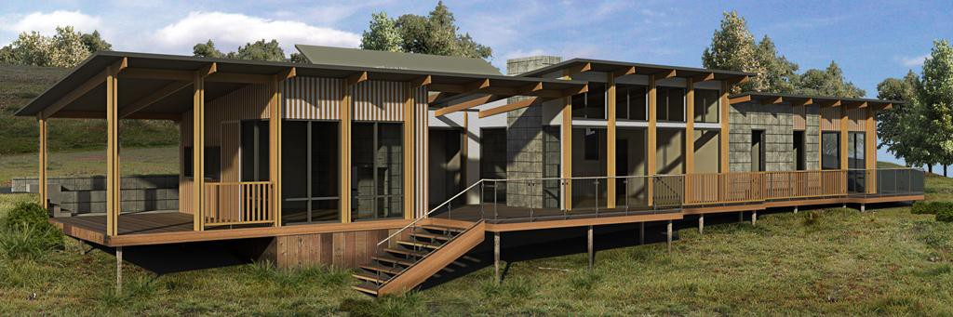

Budget, Speed & Quality
You can rest assured we know all the horror stories out there and we have both the experience and systems to ensure your build is one of the successes rather than the vast majority that result in nightmares for the client.

Enough, let's focus on the positives! There are 3 components to any build. They are budget, speed and quality. Naturally, you would like all 3 and that can be achieved in balance, but it's important to note they are all linked so we need to get clear at the beginning. What is your number one priority?

Just because you choose budget doesn't mean you will end up with an inferior build. Just like paying over the top will not guarantee quality. But, budget will always be a top priority for both of us and all subsequent decisions will be made with that in mind.

If you need speed then be honest with your deadline. If we cannot meet it we will not waste your time. Equally, you should insist on a Gantt chart (Timeline plan) from whoever tenders for the work. This will ensure the handover date has been planned. If your trades business cannot (or will not) provide this information then they are incapable of achieving a successful outcome. No exceptions, this is a fact. The trades business is kidding himself if he tells you differently, don't let him kid you as well.

Quality is often talked about and rarely delivered in residential construction. It is linked to speed because it takes longer to deliver a higher standard of work. It also means that the supervisor will be far more confident getting substandard work redone if he is not working to an immovable time line.

So, the first question I need to ask is, what is your number one priority? You can say all three if you wish, that is fine, but I am now working in your interests so it's good to know if there is a pressing constraint involving a budget or completion date.


Deciding on your home design:
The beauty of building is that you can create the home you want. It's a great idea to start out by making a list of 'must haves' and 'nice to haves' so you can ensure your home has the things you value most.

Don’t skimp here. You want an expert architect that specialises in what you want to build.

If you’re building a custom new home and you want to make it special, this is where it starts. You need an expert in the field. You will get twenty times back on what you might save by having a poorly designed home in end value.

I see many plans and l always look for first impact, what the house looks like from first sight from the street view. Normally the elevation drawing from the street is where you want the wow factor. I then look for difficulty to build and whether it’s a practical design. It is a great idea to run the initial plan or sketch plan past a specialist trades business before you fully commit to a working plan. Small changes may need to be made that affect the appearance to build it or the changes may save tens of thousands of dollars on build costs.

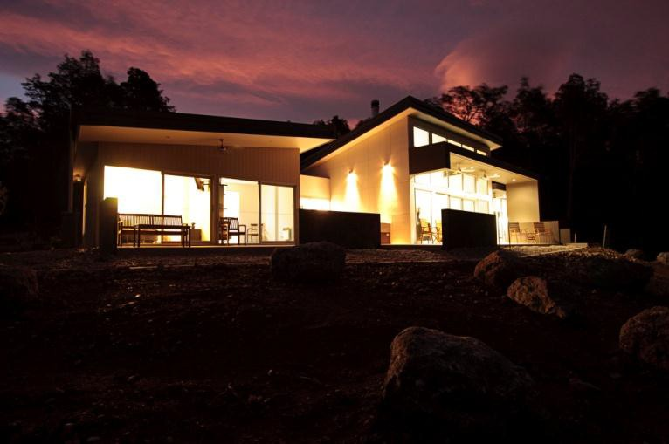

Here are some things we suggest you consider:

SINGLE, DOUBLE OR SPLIT LEVEL?  This may depend on your land if you already own it, but it's also a decision influenced by the people who will live there. Single storey homes are great for larger blocks and are easier for young families, or those who find it difficult to climb stairs. Double storey homes mean you can fit a larger home on a smaller block and maximize backyard space, this option is also ideal for families who are looking for space to be together, yet who also want privacy.  HOW MANY BEDROOMS?  This will depend on how many people will live in your home, how often you have visitors stay over, if you have any other interests - such as a music room, library or home theatre. A home with bedrooms close to the principal suite is great when you have small children, and for those with teenagers, a little more distance between living quarters may be preferred.  WHAT FIXTURES AND FITTINGS DO YOU WANT?  Consider the level of inclusions you would like based on your budget. We offer a Classic range as standard. Ask us for a complete list of what is included.  WHAT DO/DON'T YOU LIKE ABOUT YOUR CURRENT HOME?  Think about what you'll miss, and what you're looking forward to in your new home. Sometimes it's small things like power points being near appliances, and sometimes it's big things like having more room for your favourite hobby. | HOW IMPORTANT IS LIVING SPACE?  If you have young children, several different living zones are ideal. It's important that they have somewhere close to the kitchen and main living area where they can play, and be seen. With teenagers, you'll probably want it the other way around.  If you're an avid cook or entertainer, the kitchen will no doubt be the hub of your home. Be sure it can accommodate your needs in terms of space and that it has an open-plan layout so it integrates with the rest of the living area.  HAVE YOU THOUGHT ABOUT SUSTAINABILITY?  Sustainable homes provide greater comfort all year round, significant cost savings, and are better for our environment.  HOW MUCH OUTDOOR SPACE DO YOU WANT?  How you're going to create space outside will depend on the design that you choose, so consider this carefully, including views and gardens. Adding an outdoor deck or alfresco area can create an indoor-outdoor living environment that's great for entertaining, and will encourage outdoor living.  CHOOSING YOUR LAND.  Depending on whether you already have land or you're still looking, this must be considered hand-in- hand with selecting your design.  WHAT IS THE LAND'S WIND RATING?  As Australia has varying climatic conditions, it is  important to consider the wind rating on a property as it may result in additional construction costs.

WHAT COUNCIL AND DEVELOPER REGULATIONS EXIST?

Local council regulations can influence what you can and can't build. We can help you determine what restrictions your council may have in place. Some developments also have what's called a 'covenant' - a set of design guidelines that ensure a certain standard of home is built within that development.
While this can mean further restrictions on what you can build, covenants do also protect your investment as you can be sure that other homes in the area will be built to a similar standard.

HOW DO YOU WANT THE OUTSIDE TO LOOK LIKE?

How your home looks from the street creates a first impression, so it's important that it reflects your style. Consider the many different façade options available, which ones suit your look and which design matches the amount you have to spend. Some façade treatments may be subject to council or development requirements, so it's important to be mindful of these.

WHAT IS THE SIZE AND SHAPE OF YOUR BLOCK?

This is going to determine the type of home you can build. The most important aspect here is the width, as homes are designed to a certain width, but can sometimes be lengthened or shortened. Find out if there are any 'build envelopes', easements or causeways - as these will determine where the home can be built on the block. The person selling the land should be able to tell you this, as well as provide the necessary documentation for your trade.

WHAT'S THE ORIENTATION OF YOUR BLOCK?

The orientation, or the direction your block faces, is another important consideration. As you will want to make the most of the sun's natural energy for comfort as well as for energy efficiency, the direction the block faces will influence the design you choose.

WHAT ARE THE LEGAL SURROUNDS?

When you build a new home, both local and state governments have regulations and requirements that ensure the safety and happiness of the overall community. We will guide and assist you to ensure you have a good understanding of these requirements, and that your new home fully complies.

DOES YOUR SITE MATCH YOUR HOME DESIGN?

After choosing your home design, it's important to make sure it will be suitable for your block of land - and to determine if any variations are required, and if so, what they will cost. During this time you need to determine where you wish the home to be built in relation to existing trees, fencing and your neighbour's property.

WHAT VEGETATION EXISTS?

Vegetation on the block may have a significant impact on the build costs and home design, especially if there are protected trees which cannot be removed. Removing trees and other vegetation needs to be considered carefully, to ensure roots are properly removed before construction. If the job is in a bush fire zone, additional costs may be required to comply with requirements.

WHAT TYPE OF SOIL IS THERE?

The soil on a block of land is classified by geotechnical engineers according to a recognised Australian standard. Classifications range from stable sites through to blocks of land where there are expected to be varying degrees of surface

ARE THERE ROCKS?

The presence of rock on a block may not always be obvious and can result in additional costs during construction.

IS IT A TIGHT SITE THAT'S DIFFICULT TO  ACCESS?  Sites of this kind may require extra costs due to additional deliveries, manual handling of materials and clean-up of the block. Traffic control may also be needed over the life of a building. As soil classification relates to the reactivity of soil to moisture change, all issues with soil movement are water-related - either too much in times of high water volumes or too little in times of drought. | WHAT IS THE SLOPE OF YOUR BLOCK?  When you're considering your land, you need to be aware that as a general rule, the higher the fall, the higher the earthworks and retaining costs. The size of the block also makes a significant difference to the amount of fall which is acceptable. For example, a 3m fall on a block that is 1500m2 would have less impact on costs than a 3m fall on a block which is only 350m2

What Now?
Once you've thought about all of these factors, we suggest you speak with us at Build On - we can provide you with help and guidance as to local council requirements. To make this appointment valuable, you should decide on the following and bring detailed information if possible:
- The type of cover you want for your car
- Your preferred front facade (elevation) style
- How your home will sit on your block, taking into account future plans (e.g. gardens, patios, pools).
The following information would also be helpful, if available:
- Current rates notice
- Details of your land - a block plan (survey)
- Details of any applicable covenants for your home site
- Sewer diagram. This can be obtained from your local water authority



Checking your quotes:
If you request a quote from a trades business don't be too surprised if it is only a page or two. I'm not saying that is acceptable but it does tend to happen.

If you went to buy a new car you would expect to receive a full specification, options and a detailed price. So why is a trades contract so different when it can be over 30 times the price of your car?

The reason is to do with how the industry has evolved. Typically, Design & Build is too difficult for project home trades. They target clients building their first home as they are more likely to be guided and less likely to complain which protects their margins.

The client that wants something a bit better (or has built with a project business previously) is attracted to the design & build market due to the higher level of quality and the flexibility to customise anything. The trades in this market are typically small and build between two and six homes a year. They started out as carpenters straight from school and have progressed to becoming trades.

The problem is, a great carpenter does not equal a good business person. Although they can build a beautiful home they are unable to detail the components. This leads to misunderstandings and disappointment on both sides. Most trades are not crooks and do not set out to deceive clients, however, a lack of academic skills and the complex nature of putting together over 250 different activities into a compact timeline and identifying the critical path leads to stress for the trades business and frustration for the client.

To help avoid misunderstandings and to ensure you are comparing apples for apples make sure the following questions are answered and included in any quote.

  - Is temporary fencing included in the quote?
  - Are the site works, footings & slab quoted as per soil test
  - What is the finish to the soffits?
  - What is the specification for the hot water system?
  - Are all sediment control measures & fines included?
  - All approvals, insurances & certification included?
  - Is the site left clean and tidy with any excess soil & rubbish removed?
  - What bathroom accessories are included and which models?
  - Are insulation batts included to all external walls &ceilings? (If so, what rating?)
  - Are supplier delivery charges included?
  - Are the internal WC's externally vented? (BCA Requirement) What is the specification &furniture for the internal doors?

  - How many ceiling manholes are included?
  - What is the finish to the driveway?
  - What type of splashback is allowed for in the kitchen?
  - Is the letter box included?
  - Site identification survey included?
  - Footings & slab engineer inspections (& re inspections) included?
  - Engineers frame inspection included?
  - What insurance included?
  - Who is the colour consultant and how much time has been allowed?
  - Provisioning for site access included in quote?
  - What is the handover & orientation process?
  - How many maintenance inspections have been allowed for after handover?
  - Are any external features (hoods/awnings/batten screens etc) included in the price?
  - What type & size are the robe doors & what is the fit out to all robes & linen cupboards?
  - What is the specification of the air conditioning and what percentage of the home can be cooled at any one time?
  - What is the specification for the cabinetry in the kitchen, laundry & bathrooms?
  - How clean is the home at handover? (what is the process?)
  - Is the quote inclusive of any additional materials required for 5 star energy efficiency rating?
  - What is the specification for the security system?
  - Have slabs been allowed for rainwater tank, air conditioning unit etc?
  - Is the TV Antenna included?
  - What size skirting & architraves have been allowed?
  - What size frame & what is the stud spacing allowed for?
  - What is the specification for the garage door?
  - Is gas Installation included?
  - How many coats of paint have been allowed and what is the paint specification?
  - What finish has been allowed for to the ceiling/wall junctions?
  - What length has been allowed for stormwater & sewer connection?
  - How many outside taps have been allowed for?
  - Have stainless steel washing machine connectors been included?
  - What size flashings have been allowed?
  - What is the specification for the kitchen sink?
  - What laundry tub has been allowed for?
  - What basins are included?
  - Are all set out surveys including?
  - What is the specification for the shower screens?
  - What is the specification for the mirrors?
  - What tap ware has been allowed for?
  - Is temporary power & services included?
  - Which brand of windows & doors have been included?
  - Has external rendering been included?
  - Has any protection been allowed for windows, doors, cabinetry & floors during
  - construction?
  - What is the specification for the stairs and balustrades?
  - Is the Telstra lead in included in the price?
  - What carpets and underlay have been allowed?
  - What is the specification for the external balustrades?
  - What is the finish to the garage floor?
  - What kitchen appliances have been allowed?
  - What is the specification for the water tank?
  - What tiles have been allowed to the walls & floors? If it is an allowance what size and quality does the allowance cover?
  - What height is the tiling in each wet area?

A quote should typically be around 30-40 pages to capture all the detail. Anything less than that is ambiguous and leads to an increase of over 36% to the contract price by completion.

Example of a construction schedule - Gantt Chart (Timeline plan)
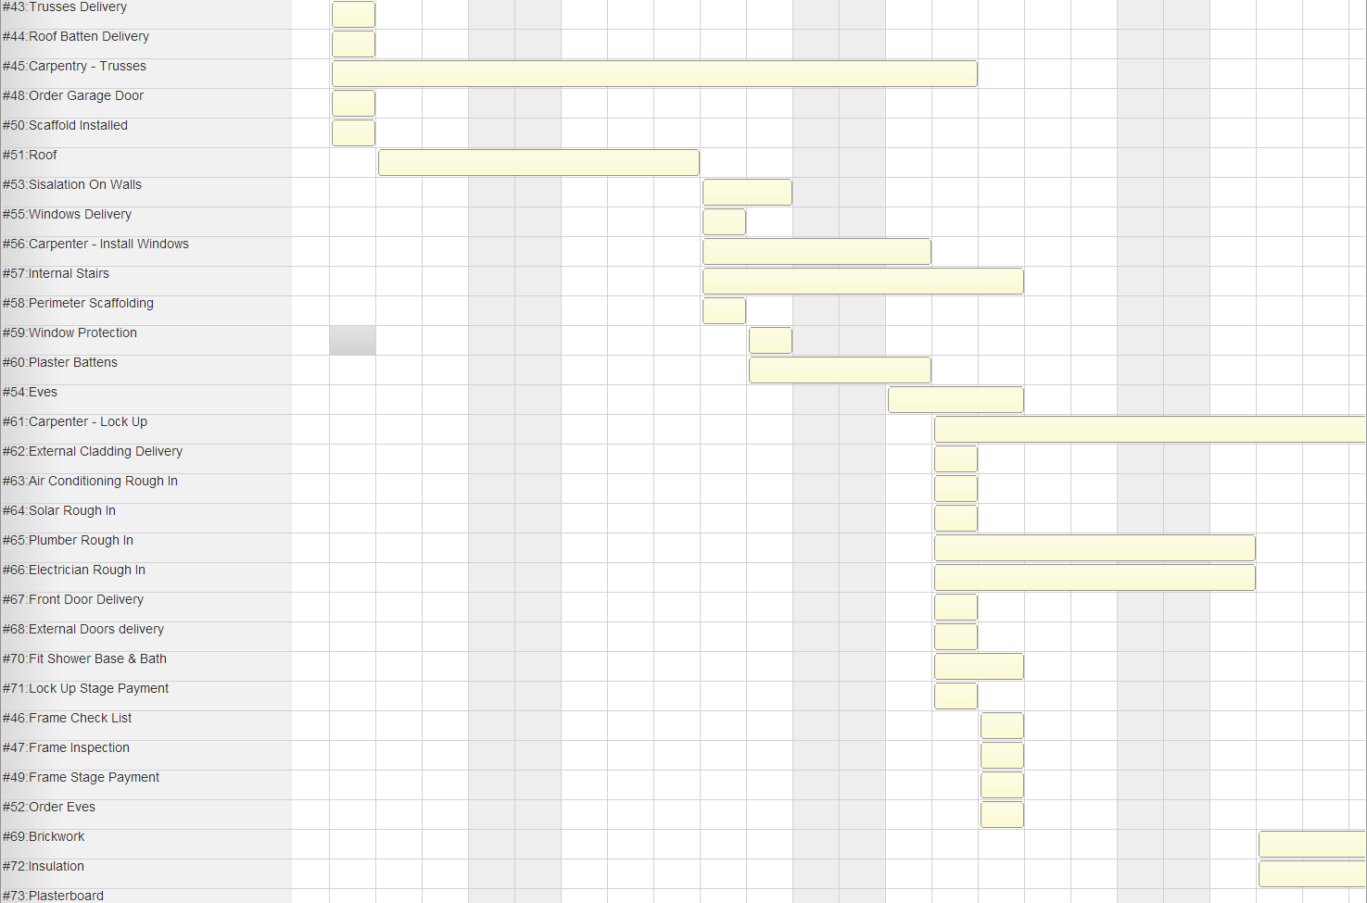

Handy Hints:

- Make sure your house and land work together
Ideally, you should start looking at available land and home designs at around the same time. You don’t want to buy a block only to discover it's not easy to find a home to fit. Nor do you want to fall in love with a design that can't be built on your chosen block. Also, you need to make sure both the home, and the block, are within your budget.

Becoming familiar with the opportunities and limitations of different blocks and designs will give you a greater ability to ultimately choose the right home and land together.

In a sense, the block or lot will help to determine the home design, as the location, dimensions, orientation and condition of the lot could influence which design would be best.

And remember, whatever you do choose first, you can't sign a contract to build a home design without having already signed a contract for the land.

A house and land package is often a good way for people looking to build, as the task of finding the right home for the block has already been completed. There is also a price associated with the package which makes it easier to determine whether it's within your budget.

Build for long-term energy efficiency
Ensuring that your home is as energy-efficient as possible can certainly save you money on energy bills over time. Plus, you can enjoy the peace of mind of knowing you are doing your best for the environment.

Energy-efficient considerations can include:

Solar orientation of your home:

How your home is placed on your land is very important. The 'ideal' home has the daytime living areas facing north with the long axis of the house running east-west. In the real world, this is fairly rare, but the good news is that variations on the orientation can be up to 30 degrees to the east and 20 degrees to the west of true north, with no major effects on the solar advantage.

Design and layout:

Your home's design and layout can also play a significant role in reducing energy costs. For instance, having daytime living areas facing north captures the winter sun. When you tile these areas, the rooms warm up even more in winter – while effective eaves and blinds keep them from being too hot in the summer.

Having an open plan style of home will also help. This makes the best use of all available space, and should also allow light to penetrate easily and air to circulate freely around the home. However, you should be able to close off areas to contain warmth when needed.

Insulation:

Wall and ceiling insulation is another effective way of minimising the need for heating in winter and cooling in summer. Up to 40 per cent of winter heat can escape through a non- insulated ceiling and about the same amount of heat can be stopped from entering the home during summer.

Windows and shading:

While north-facing windows and doors let in the winter sun, in summer you may need suitably designed eaves or pergolas to keep the harsh summer heat out.

In areas of extreme heat, external blinds or shutters are a great idea. In the cooler months, our homes lose the majority of their heat through windows and sliding doors.

Close-fitting drapes, blinds or internal shutters trap a layer of insulating air between them and the glass and make a big difference to how much heat escapes.

Landscaping:

Out in the garden, you can establish shady deciduous trees to help block the summer sun. Of course, in the winter, they allow the sun through to warm and light your home.

Ideally, you should place them as far from the house as possible so you still get shade - but don't need to constantly clean out your gutters or create bush-fire danger. It is also important when planting trees to refer to your Guide to Home Maintenance to ensure you are positioning the trees in suitable locations, so not to disrupt your footings with the tree roots when they grow.

If you've built pergolas, plant them out with attractive vines that again will allow sun to shine in winter.

Heating and cooling:

Lastly, the heating and cooling devices you choose for your home will have a major impact on your energy efficiency - and your bills.

Choose a gas heater or high efficiency reverse cycle air conditioning system. If the system has adjustable louvers, adjust them towards the ceiling when cooling, and the floor when warming.

Get familiar with any legalities or restrictions.
We are committed to creating a "common wealth" for our customers, communities and living environments. Life revolves around the home and happiness for everyone in a family begins at home. A house is a valuable asset, often the largest investment that a family makes. It is also a building block in shaping a community.

A house sits on the earth and exists through use of the earth's natural gifts. Land is a precious, finite resource and governments set the rules for maintaining its value.
Governments also set the rules for maintaining the safety and welfare of individuals and communities.

Building a house always involves meeting the requirements of a number of laws and regulations.

They are concerned with:

  - Damage to infrastructure beneath the land, for example, sewer pipes and cabling.
  - Conservation of energy resources, especially electricity.
  - Conservation of water resources, including mains water and rainwater.
  -  Conservation of the natural and heritage environment, for example, preservation of trees and native plants and landscaping requirements.
  -  Risk to building stability, for example, from land slope and underlying rocks.
  -  Risk to lives and buildings, in particular from flood and bushfire.
  -  Risk to people's health, for example, from soil with toxicity from earlier use
  -  Risk to people's privacy and enjoyment, for example, from placement of air-conditioning and outdoor dining and clothes lines.
  - Safeguarding public health and safety, for example, with security fencing.
  - It's important to have a full picture of what's involved in building your house on your land.
  - Your Sales Consultant will discuss these aspects of your land and plans with you. You can't avoid the decisions and costs of meeting government legal requirements. It's wise to keep them in mind so you maintain control and avoid unwelcome surprises.

Why m² Rates Are Misleading
The most common question a trades company hears is 'how much do you charge per m²?'

Now this is tricky. We are talking about a home that has not been designed yet so the theory is that there will be a $ figure that can be multiplied by m² to give a price. It's a vague question so only a vague answer can cover it, $600-$2500.

We can narrow that range down fairly quickly with a few questions,

  - Highset/Lowset?
  - Level of Inclusions High/Medium/Low.

Be aware that the trades business will not be making any provision for your site (Soil conditions, amount of fall, site access & area available to work in) or anything considered outside of the question such as:

  - Swimming Pool
  - Landscaping
  - Retaining

The other thing to consider is the ceiling heights and the design. If you look at the two floor plans below you will see that they are both 20m2.

However, the 'Architectural' look has 78% more wall area. If you also increase the ceilings to 2.7m that increases the external wall area to double that of the first plan. Obviously, no trades business can quote a m² without knowing what the plan looks like, but they do!

So, if you are looking to build on a tight budget, find a flat block with no fill and build a lowset with a basic external shape. We can help you even if your budget is under $200k.

Alternatively, if you are designing with an architect then don't forget, all those extra features soon add up so try and line up a trades business while you are designing. He can provide invaluable advice before you go too far.

If you are thinking of designing, talk to us first!

Inclusions:
Is the standard of inclusions important to you? Unless you are building an investment home it should feature quite heavily when you are comparing trades.

Our standard inclusions are often a topic of conversation with our clients who tell us they should be called Luxury Inclusions. But this who we are, our inclusions are a reflection of our build quality and attention to detail therefore it really is our standard.

Of course, you are not limited to these brands or models. With us you are free to change every single component as you see fit. And you can rest assured, that every change you request will be documented in the contract ensuring you get the home you deserve.

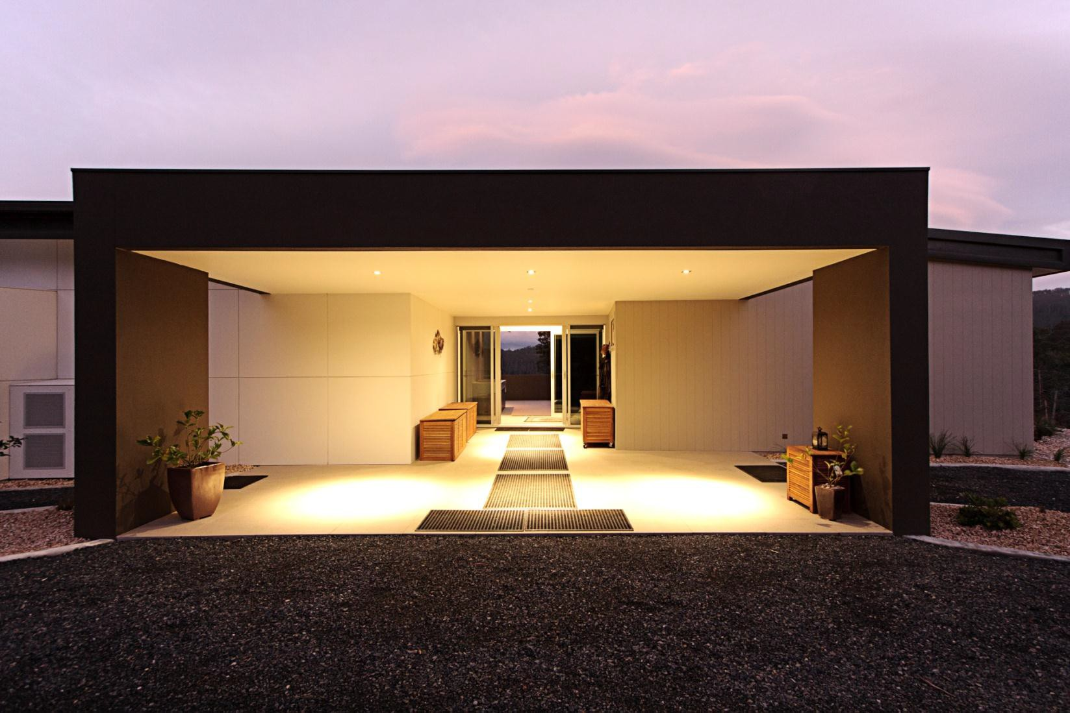

Quality Assurance Program
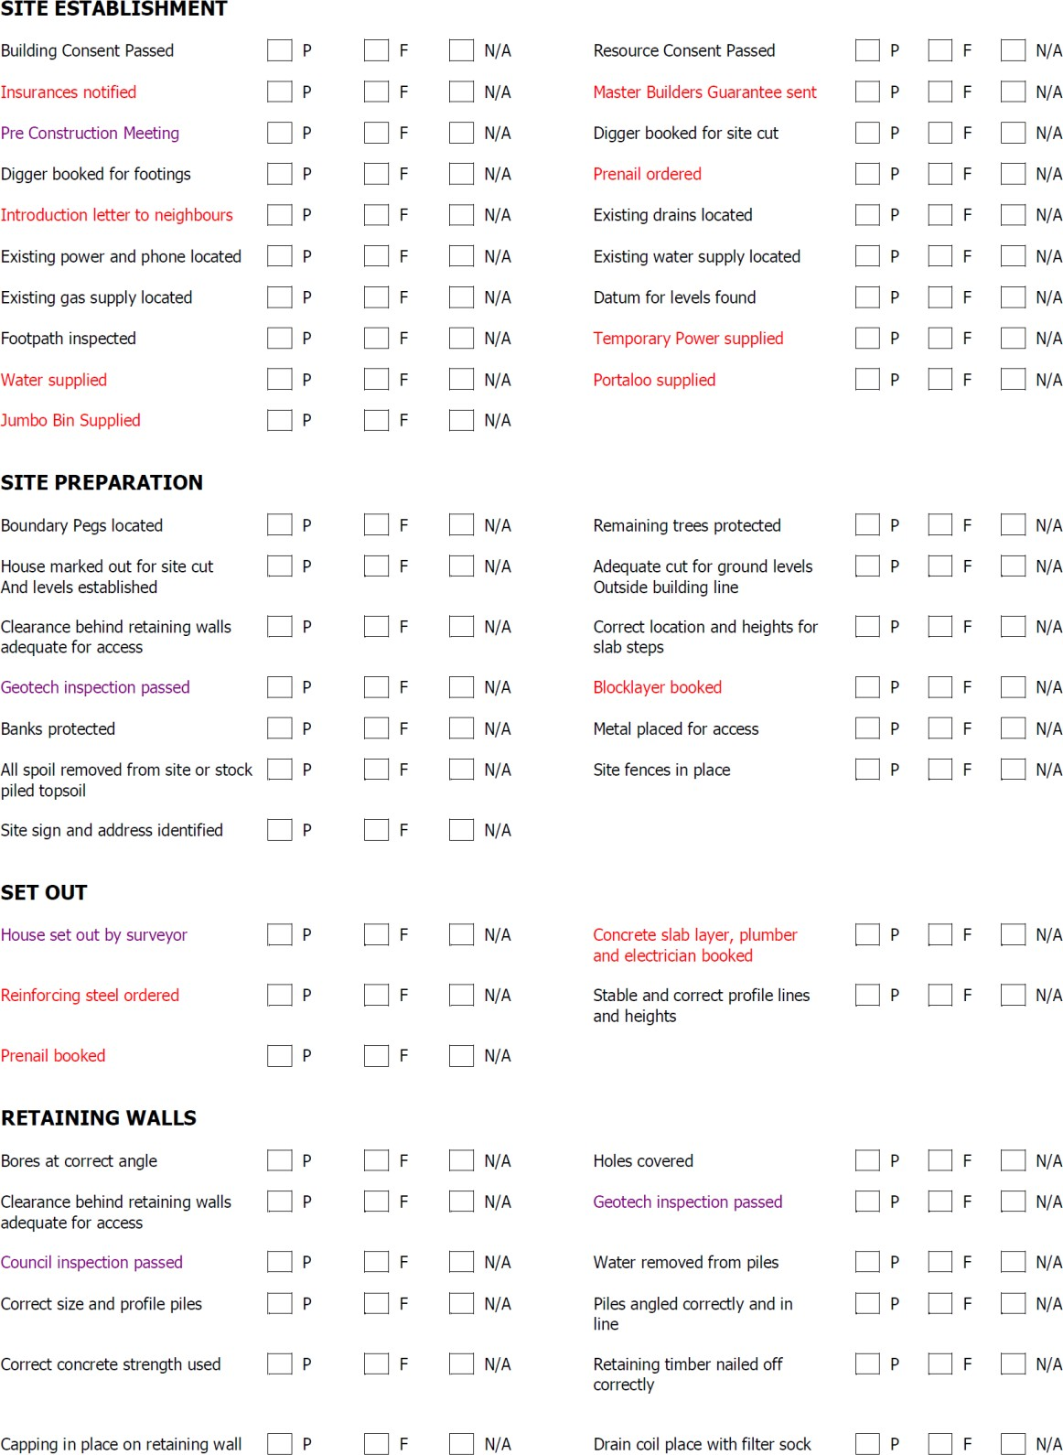

Project Information:

Client:

Address:

Suburb:

How long have you lived in your existing home? Years What things do you like, (if anything at all), about your existing house?

What are the main frustrations with your current house?

What are some of the most important things you require in your new home?

What qualities are you looking for in the Trades business/ Designer you want to work with?

When were you hoping to start this project?

Do you have an idea of what this project might cost?

Have you organised your finance? Yes / No
Have you been involved in tradeswork in the past? Yes / No

Client Selections Checklist:

External Finishes Yes (please tick) Yes (please tick)
External Walls Windows

Face Brickwork | o | Timber | o
Rendered | o | Aluminium | o
Timber | o | Sliding | o
Hardiflex | o | Double hung | o
Weathertex | o | Awning | o
 |  | Louvres | o
Roof Fascia

Tiles - Concrete | o | Timber | o
Tiles - Terracotta | o | Metal | o
Colorbond | o
Eaves Gutter

Fibro | o | Quad | o
Exposed rafters | o | Half round | o
Lining boards | o
Down pipes

Rectangular o
Round o

Decks Deck timber width

Merbau | o | 67mm | o
Mod wood | o | 90mm | o
Mixed Hardwood | o | 140mm | o
Treated pine  Other (Please specify): | o | Other (please specify):
Handrail Stairs

Frameless Glass | o | Treated Pine | o
Aluminium & Glass | o | Hardwood | o
Timber pickets | o | Other (please specify):
Solid infill | o
Stainless steel wires  Other (please specify): | o

Internal Finishes

Plasterboard Cornice

Standard | o | 55mmcove | o
Soundproof | o | 90mmcove | o
Fire rated | o | Fancy | o
 |  | Square set | o
 |  | P50 (shadowline) | o
Floor Coverings Insulation
Carpet - average allowance $35m2 | Ceiling External walls | o  o
Allowance per m2 $ | Internal walls  Under floor | o  o
Timber flooring Tiles - average allowance $45m2

Myrtle | o | Allowance per m2 | $
Brush box | o | Marble | o
Cypress Pine | o | Granite | o
TasmanianOak | o | Porcelain | o
Blue Gum  Other (please specify): | o | Slate | o
Skirting Architraves

67mm | o | 67mm | o
90mm | o | 90mm | o
140mm  Other (please specify): | o | 140mm  Other (please specify): | o
Doors Hinges

HollowCore | o | Stainless steel | o
Solid | o | Polished chrome | o
Maple | o | Brass | o
Handles Wardrobes

Lever | o | Hinged doors | o
Round | o | Sliding doors | o
 |  | Hanging rails | o
 |  | Shelves | o
 |  | Draws | o
Handrails Stairs

Frameless Glass | o | Maple | o
Aluminium & Glass | o | Craft wood | o
Timber pickets | o | Hardwood | o
Solid infill | o | Other (please specify):
Stainless steel wires  Other (please specify): | o

Services and Painting

Painting Plumbing

Outside of house | o | Hot Water Heater | o
Inside of house | o | Gas | o
Feature walls | o | Outside taps | o
Eaves & Fascia | o | BBQ Gas | o
Architraves | o | Heater Gas | o
Skirtings | o

Electrical Air Conditioning

Smart wiring - C Bus | o | Split System | o
Outside points | o | Ducted | o
Ceiling fans | o
Dimmers | o
Data points | o
Foxtel points  Power points per room Downlights per room | o

Wet Areas

Bathrooms Tiles Vanities

Tiles (amount per m2) | $ | Wall hung | o
Tiles - full height | o | To the floor | o
Tiles - Skirting only | o | Shaving cabinet | o
Tiles - 1200mm high | o | Taps $150 - $200 | o
 |  | Taps $200+ | o
Shower Toilets

Screen - Semi frameless | o | $450 - $650 | o
Screen - Frameless | o | $650 - $850 | o
Shower Head- Single | o | $850 - $1100 | o
Shower Head- Double | o | Other (please specify):
Taps $150 - $200 | o
Taps $200+ | o
Bath Laundry

Standard | o | Basin | o
Spa | o | Taps | o
Special request: |  | Washing machine taps  Power points | o

Kitchen Bench Tops

Cupboards | o | Granite | o
Draws | o | Marble | o
Soft closing | o | Ceaser | o
Standard | o | Laminate | o
Doors - polyurethane | o | Other (please
Doors - laminate | o
Splash back Appliances

Tiles | o | Cooktop | o
Glass | o | Oven | o
Stainless Steel | o | Rangehood | o
Mirror | o | Dishwasher  Power points | o

Thank You
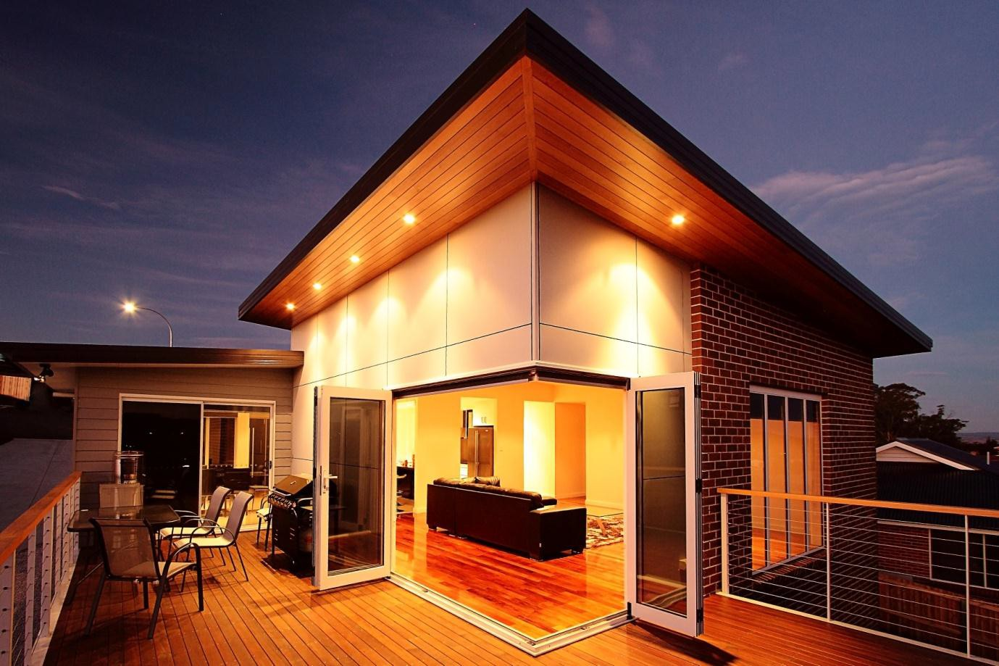

Documentation Check List

Copies | Documentation Required | ☑
4 | Certificate of Title with Schedule of Easements and Survey Plan
4 | Certificate of the Responsible Designer (TradesWork) Form 35A  (from designer/architect and engineer)
4 | Certificate of the Responsible Designer (Plumbing Work) Form 35B  (from designer/architect and engineer)
4 | Site plan drawn to scale
4 | Floor plan(s) & drainage plan drawn to scale
4 | Elevations drawn to scale
4 | Detailed cross section with energy efficiency measures
4 | Wind bracing plan including bracing type and location
4 | Certificate of Specialist or Other Person (TradesWork) Form 55 if applicable
4 | Certificate of Specialist or Other Person (Plumbing Work) Form 59 – if applicable
4 | Footing design in accordance with the relevant standards
4 | Slab design in accordance with the relevant standards
4 | Detailed framing plan
4 | Specification details provided by designer or others
4 | Geotechnical Investigation (Soil Report)
4 | Energy Efficiency Report
4 | Environmental report for the disposal of onsite waste water if required.
1 | Signed Owner Trades Business Declaration IF an accredited trades business is not engaged
4 | Cradle Mountain Exemption form OR Certificate of Certifiable Works
4 | Planning permit OR exemption

Note: This is a guide ONLY. Further information may be requested by the Building Surveyor









