_{a}
COST TO BUILD BLOG
XYZ TRADES BUSINESS





What does it cost to build a new house in Melbourne?
The biggest mistake most people make when planning a dream home is not understanding build
costs. It’s very easy to think that $1 million is lot of money for a home but if that has to include everything from GST to fees of all the consultants, you are actually left with significantly less for the actual build cost. This article aims not only to discuss the costs of building a house comprehensively, but also to outline aspects involved in building and how they affect costs.
In Melbourne, we generally gauge a building’s construction costs through a combination of size, quality, and level of difficulty. These three aspects can give a very rough indication of feasibility, but there are many other factors that affect the cost such as time-frame, site access, site context and conditions, level of technology, luxury appointments, and degree of energy efficiency. Architecturally designed homes, however, will often have further factors such as the level of detail, complexity of structure, and then of course the architects themselves.
The most expensive build is thus one that includes all of the aforementioned factors. Unless you have an open cheque book, having it all is not always possible and there often needs to be compromises. While there may be a desire to include everything, the reality is that not everything is actually needed and a good architect can assist in determining the priorities and determine what is achievable, appropriate, and ultimately feasible. Preference for a very large home of high quality, for example, might require a smaller building company who may take longer, while also foregoing some luxury items such as a swimming pool, home theatre, or lift.
Architects may be seen as magicians but they are not miracle makers. While we can design spaces to feel larger, be light filled and uplifting, we can’t physically make spaces bigger or introduce quality finishes without affecting costs. We can make the most of a sloping block and be sensible about how energy efficient the house might be, but if the block is badly orientated, sloping, or has poor soil conditions, we can only do the best we can with existing conditions. Magic as we all know is just an illusion.
Let us expand a little on some of the main points affecting building costs:

SIZE
Naturally, a larger house requires more materials, more labour, and sometimes even more specialised equipment to build, particularly if it has physically larger elements such as bench tops or glass window panes which may require cranes, scaffolding, or cherry pickers to assist with installation. A larger house may also take longer unless a larger team is employed for the build. At XXXXXXXXXXXX it is not in our nature to be wasteful, so we are always looking at where we might trim off some fat and in doing so reduce building costs.

BUILD QUALITY
High quality materials, finishes, and fittings naturally increase costs, but this is due to more than just the raw materials themselves. Better materials demand better finishing and craftsmanship and the labour costs increase proportionately. Inexperienced tradesmen will potentially damage quality marble tops or timber floors. A Trades Business who understands how things work will be required in order to schedule works properly and provide adequate protection to the materials both during and after installation. At XXXXXXXXXXXX, we believe in only investing in quality finishes and fittings where it is most effective in terms of purpose and impact. We work to get the most out of our clients’ investments and sometimes a strip of marble at eye level, which can be touched, is of more value than a whole room clad in the same material.

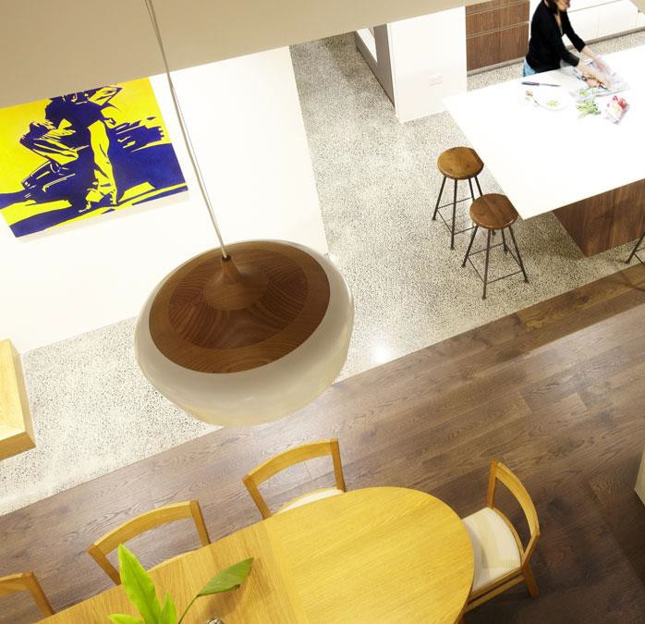

COMPLEXITY OF DESIGN AND LEVEL OF DETAIL
Architects are the only professionals trained to get the most out of space. Our ability to create the illusion of something being grander, larger, and imbued with light, beauty and meaning has earned us the reputation of being magicians. This standard of design, however, can add to costs as voids, split levels, open plans, and spaces that connect cleverly together often require structural designs beyond the norm. Complex structures will not only be harder to conceive and assemble but the structural members and materials themselves will add to costs.

With regards to the details it’s most economical to use what we might call standard details incorporating simple but conventional skirting, cornices, and architraves, with standard door and window sizes, etc. These are universally understood and available as opposed to components that have to be imported, customised, or carefully constructed. Clients, however, rarely use architects to obtain average or standard details, so having a clear understanding of how elevating the level of detailing impacts cost is critical to keeping within budget.

TIME FRAME
Finishing a project quickly is not about rushing and therefore increasing the likelihood of careless mistakes. It often involves having a larger team on board to get more done. At the same time, adding more people to the team doesn’t automatically mean that work will progress faster. You must ensure that each individual is experienced and able to coordinate with the other team members effectively. A Trades Business with a large team of experienced tradesmen who is able to guarantee deadlines will command a premium. A sole operator will be a much cheaper option per day, but could take significantly longer.

SITE ACCESS AND CONDITIONS
Trades need good access for delivery, storage, and use of machinery. A tight inner-city site or
renovation project will be a costly logistical challenge. Sloping blocks also present challenges and it’s not uncommon for build costs to increase by as much as 30% where the slope is steep. The soil conditions also affect the type of foundations and if you hit rock while excavating, the costs will blow out even further. Another potentially problematic condition to take into consideration is when building near a water source such as a beach, or lake, or on a flood plain. Furthermore, building on or near a boundary shared with another building or trees requires more complex forms of support and protection. This is why most build and construct type display homes are only possible on regular, flat blocks. If the site has inherent complications, you need a good architect to make it work or risk it being a mess.

TECHNOLOGY & LUXURY ITEMS
Technology should always be considered a luxury, especially with the amount of choice, control and wizardry of modern smart systems. Swimming pools, basements, home theatres, and lifts are all items that many of us want but don’t realistically allow for when calculating cost. A basic rectangular swimming pool, for example, might start at $60,000 and seem affordable, but when you add in the pool fence, cover, heating, and self-cleaning, the cost can easily double. On top of this, add designer tiles, an infinity edge, a spa, a little more length to allow for laps, and what once was cheap is now very expensive. This kind of cost escalation can also occur for home theatres, lifts, and basements and this is why those items are often not included initially when working out basic building costs.

ENERGY EFFICIENCY
With the minimum energy rating in Victoria now at Six Stars, it’s almost impossible to escape double glazing and insulation, which have increased average building costs in recent years. While most XXXXXXXXXXXX designed homes aim to achieve 7 Stars or higher, it can be very expensive to go beyond six. Hydronic heating and off grid power sources from solar or geothermal energy are not cheap and few clients will extend their budgets to accommodate these despite the long-term benefits. Incorporating recycled materials can also prove troublesome as they can be difficult to source and implement as well as being more labour intensive.

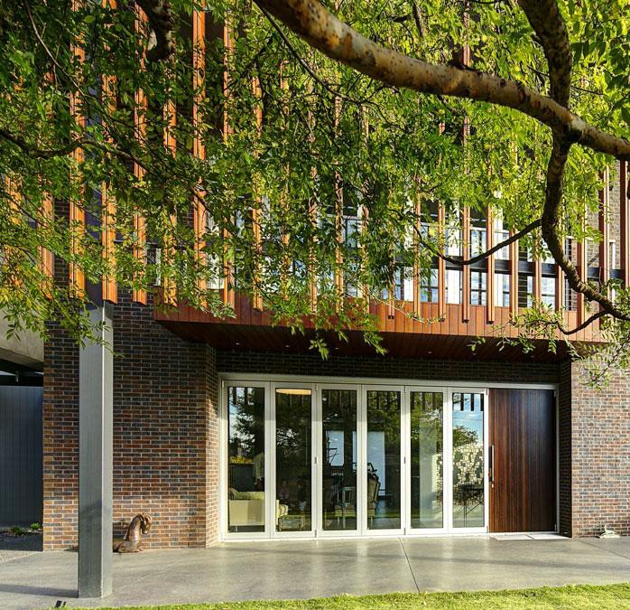

So what exactly does it cost to build?
Experienced architects and Trades Businesss can discuss a project in brief and have a gut feeling for the overall costs within 20% of accuracy. For the average person, however, it is unfortunately very hard to calculate build costs without involving a quantity surveyor or other professional cost estimator. As a very rough guide, and for the purposes of this article, we will assume an average build cost per square metre. Note, however, that this can only be a rough guide as the cost per square metre to build a basement or garage will differ vastly from the cost per square metre of a kitchen.
At XXXXXXXXXXXX, we have five categories for our residential projects with Category 1 projects averaging around $1 million + GST, progressing up to Category 5 projects with budgets in excess of $5 million + GST.

From our experience, it is unrealistic to have a fully architecturally designed home that falls below a Category 1 rating and for such projects, we suggest a minimum build cost of $2,500 + GST per square metre. These projects can comprise durable materials that look well and feel contemporary, must be readily available and their installation not too labour intensive. With regards to design, the brief should be met with a floor plan and look that is reasonably unique and contemporary. Such a house could not be overly complex in structure or build. Luxury extras would need to be minimised.

Unfortunately, $2,500 + GST per square metre does not go far and most clients at XXXXXXXXXXXX opt for Category 2 or 3. These homes range between $3,500 + GST and $4,500 + GST per square metre, and allow for a higher level of luxury. Our top end homes in Categories 4 and 5 will impress in every aspect and can cost anywhere from $5000 + GST to $10,000 + GST per square metre. Note that these figures are for the build only. Other costs to allow for are:

- Luxury items such as swimming pools or smart technologies.
- Landscaping and fencing which could easily require a further 15%.
- Any demolition of existing buildings, removal of asbestos, and other site preparations or protections
- All consultants and costs for permits and approval

Building costs less than $2,000 per square metre are achievable, but at this rate it would be unlikely that an architect could be involved, and therefore such projects usually don’t result in good value. While “build and construct” companies can offer new homes at significantly lower costs, caution must be taken regarding exactly what will be delivered. Display homes can be seductive, but keep in mind that they are mass produced products and like all such products the quality will be poor despite presenting well. Fast food commercials always look tempting and while it may be fine to indulge every once in a while, they offer an unhealthy option and when it comes to something as significant as your own home, everyone deserves the best.

Architects’ fees

Architects’ fees are complicated to calculate because they can cover an extensive range of services and roles. While they do not normally form of part of calculating build cost, they do need to be considered as they can be significant. For more information on architects’ fees we suggest you read our article, What Does it Cost to Use XXXXXXXXXXXX?
However, for the purposes of this article, we offer here a very brief guide. There is a relationship between the cost to build and the cost to design but it can be a bit arbitrary. For many years architectural fees have been assumed as being 10% of a building’s construction cost, but we believe that this can only be used as a guide or starting point and is unlikely to include other services such as interior design, town planning or contract administration during the construction phase. If 10% seems too high then having an architecturally designed home is probably out of question. If 10% doesn’t make you flinch then you should determine exactly what that 10% includes. It may be far too little for clients expecting high end service with everything included.

We suggest that the architect’s fees be assumed to be between 10% and 15%. It is also important to consider, however, the quality of the work and the efficiencies of the practice. Practices with reputations for efficient, award winning work that truly delivers happiness to their clients can justifiably charge fees in excess of 15% for residential projects.

Budget allowance calculation example?

- A 300-square metre house built at $3,000 + GST per square metre= $900,000 + GST

- Site conditions: for a significantly sloping block with limited access, allow and extra 10% of$900,000 = $90,000 + GST

- Luxury items: for a heated swimming pool with cover and self-cleaning capability, allow and extra $100,000 + GST

- Landscaping and fencing: allow an extra 15% = $135,000 + GST

- Existing house demolition and site preparation: allow an extra $20,000 + GST

- Architect’s fees including interior design: allow an extra at 12% of $1,115,000 = $138,600 + GST

- Other consultants and fees: allow an extra $20,000 + GST.

TOTAL BUDGET ALLOWANCE = $1,363,600 + GST= $1,499,960
From the above example, we can see that someone with $1 million wanting a 300-square metre house might assume that they are ready to proceed, but after considering all factors, they might in fact be almost half a million dollars short.

